1>>>

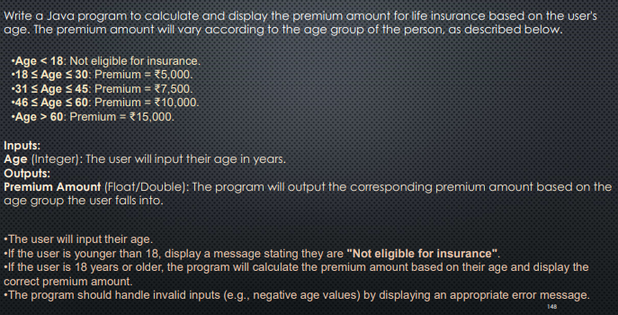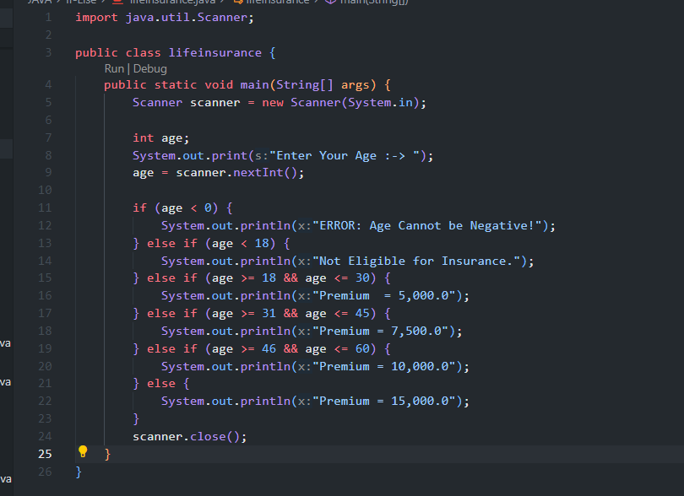

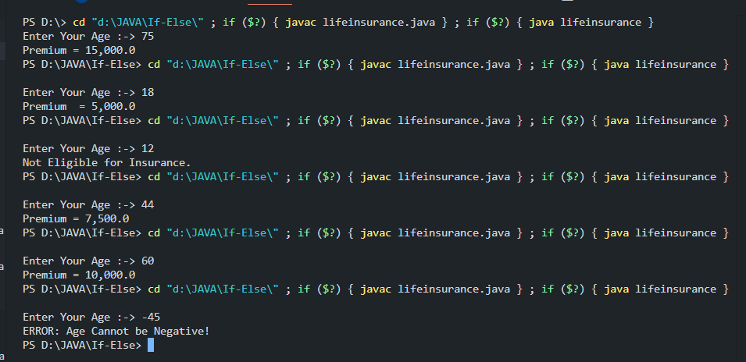

2>>>

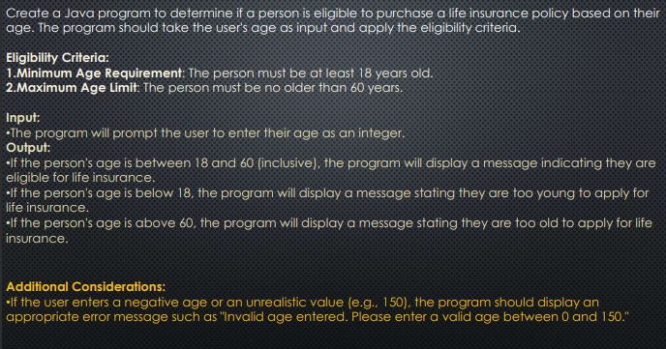

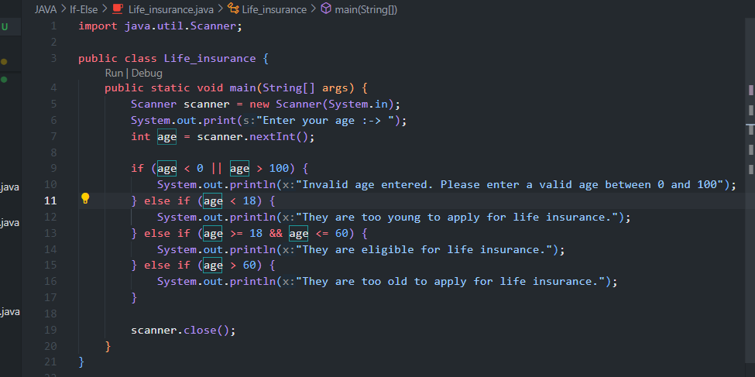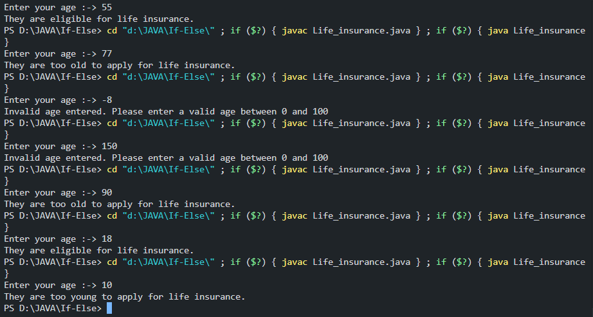

3>>>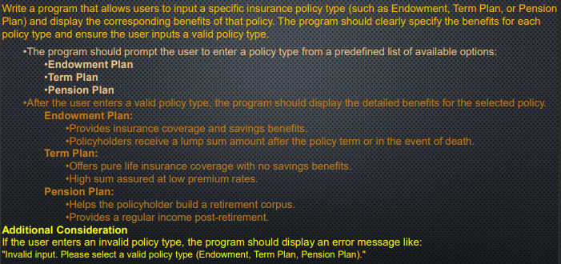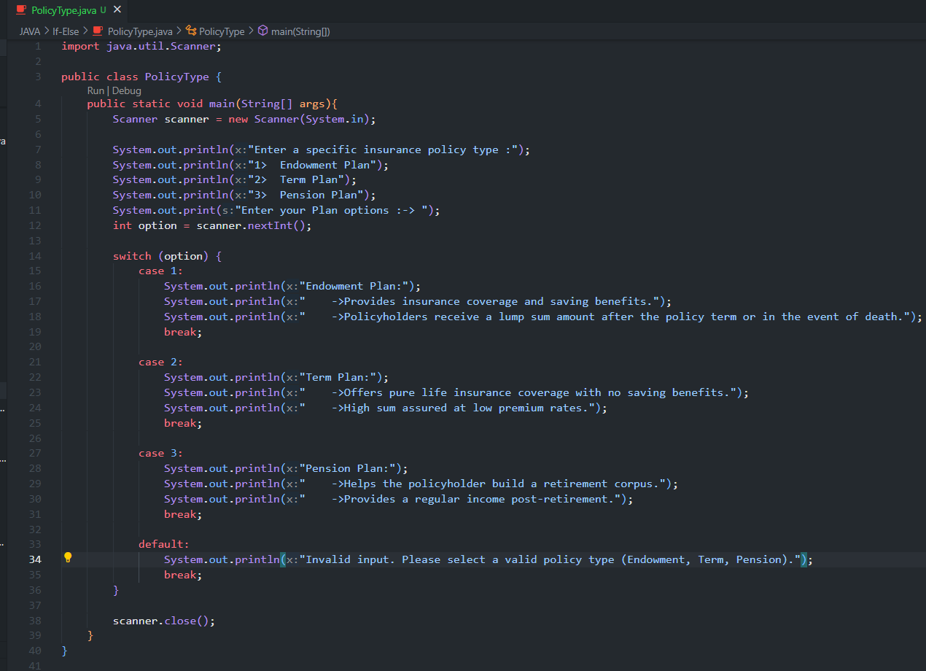

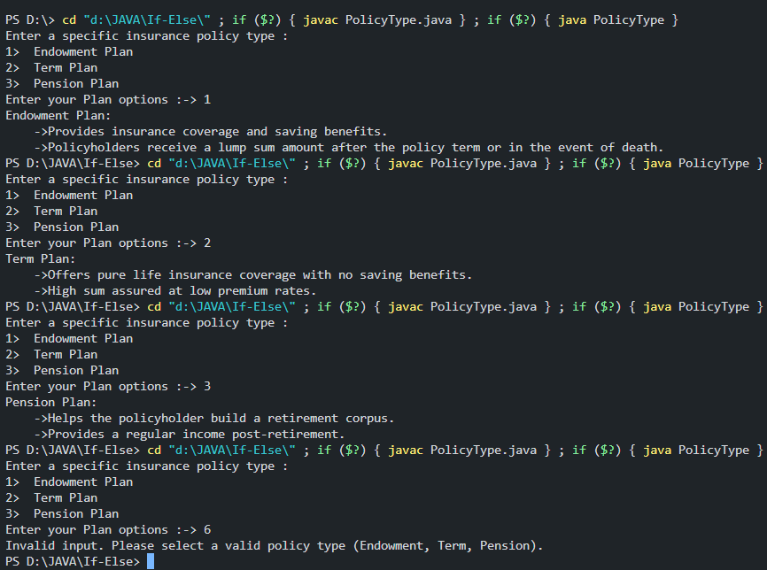

4>>>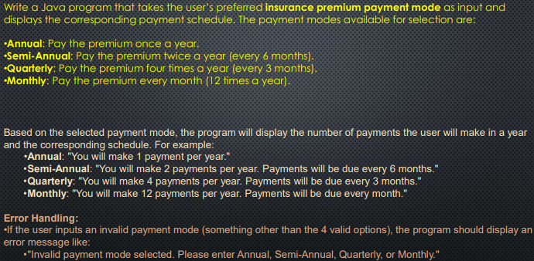

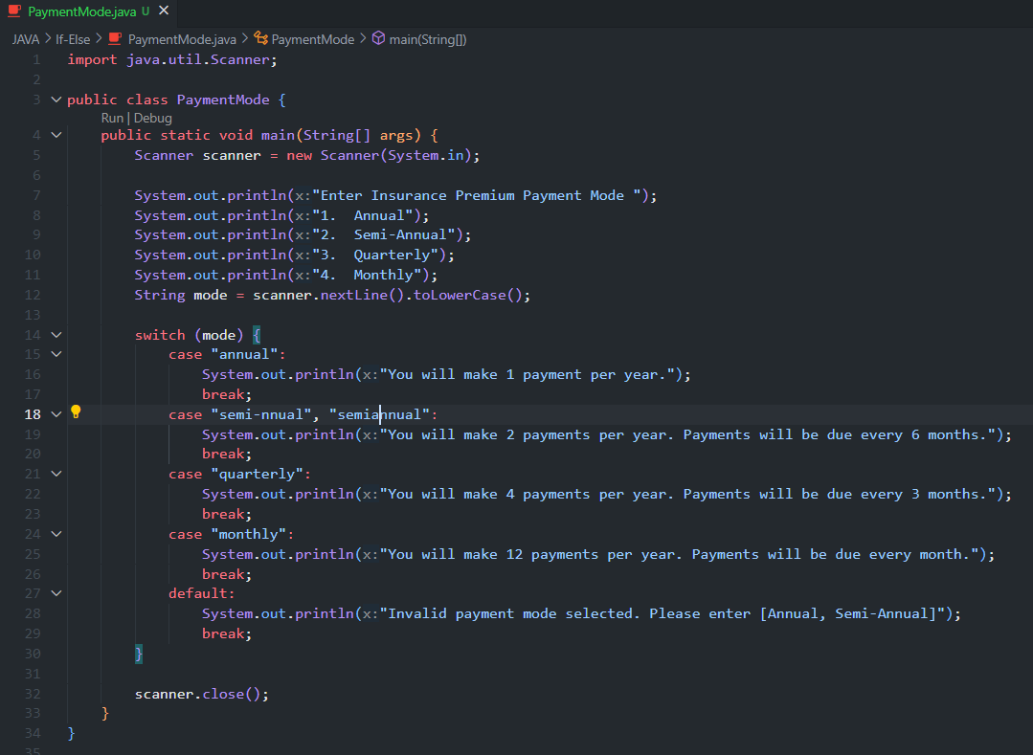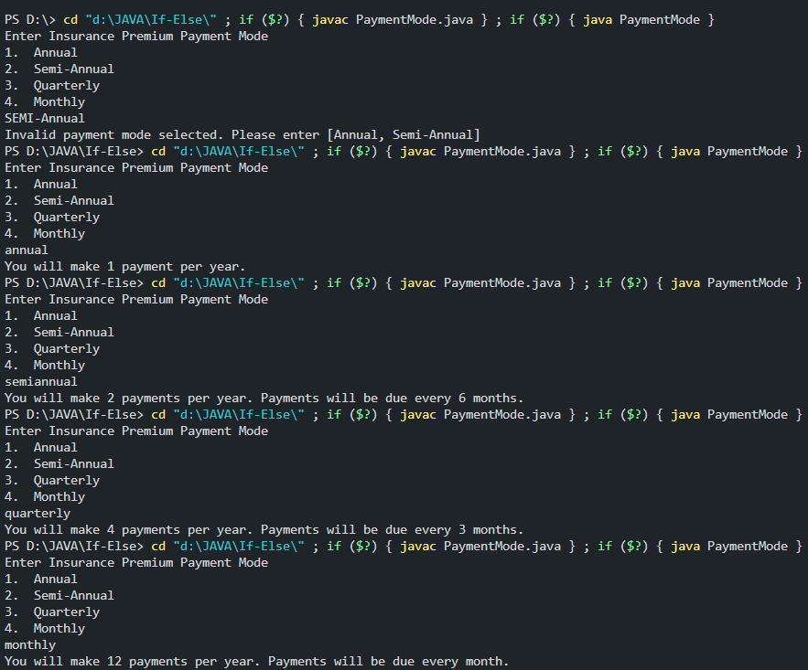

5>>>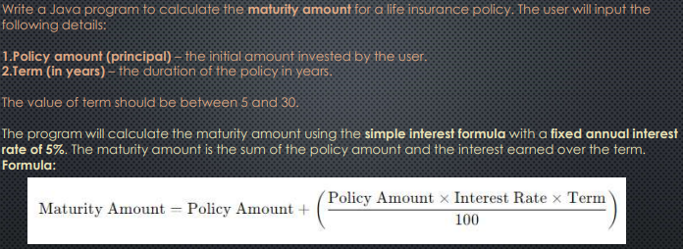

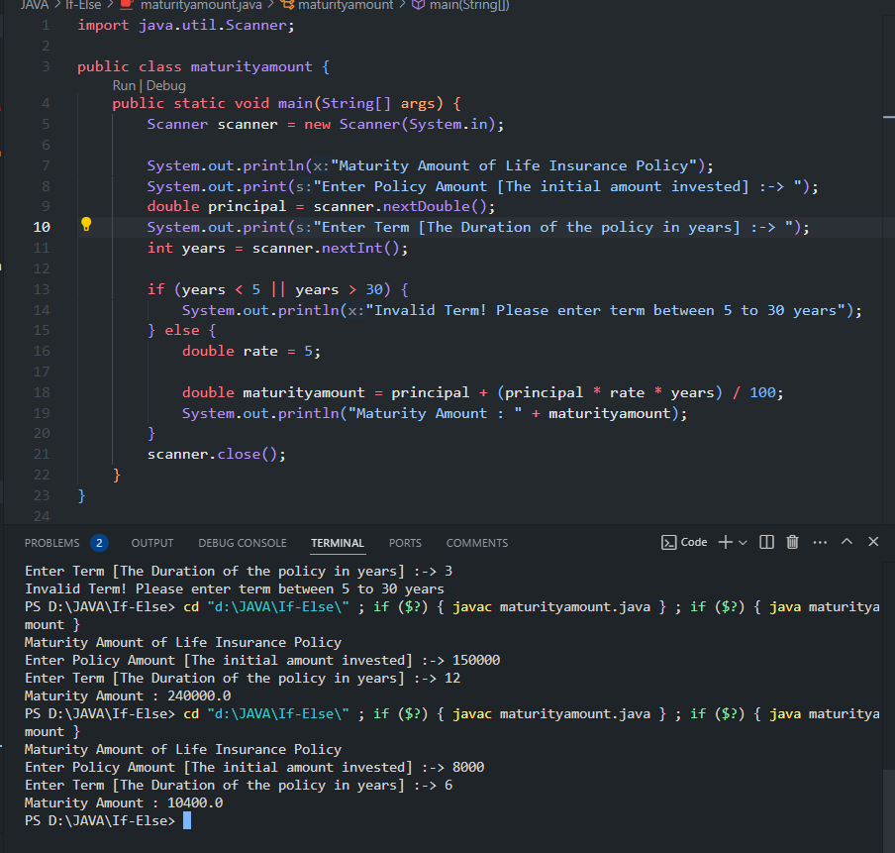

6>>>

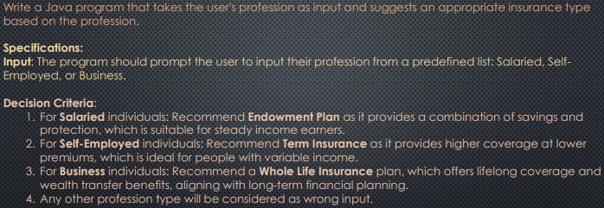

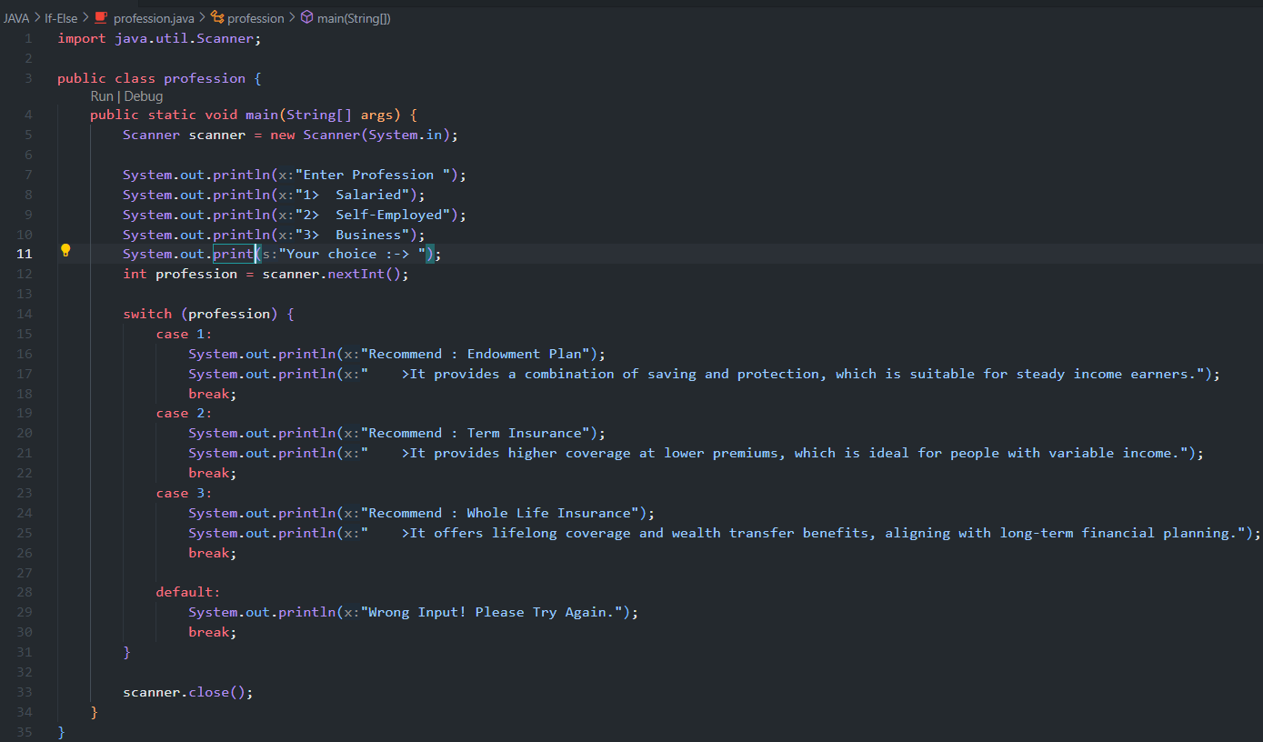

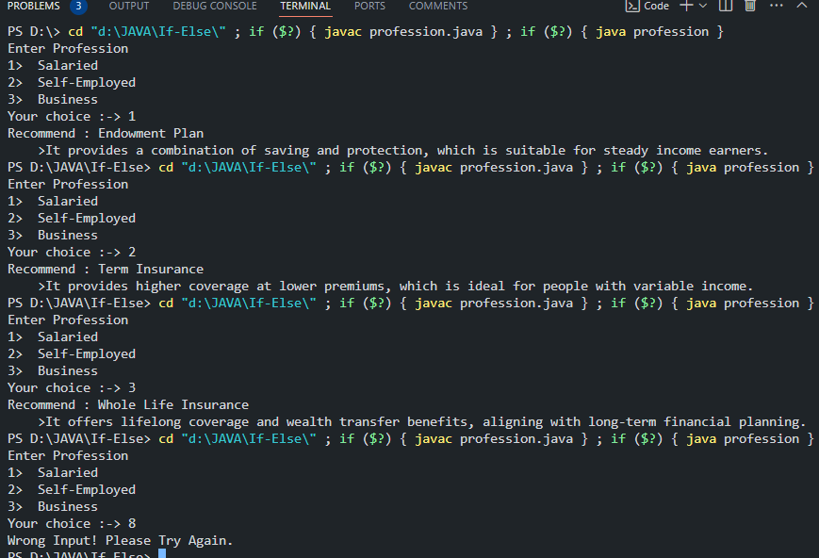

7>>>

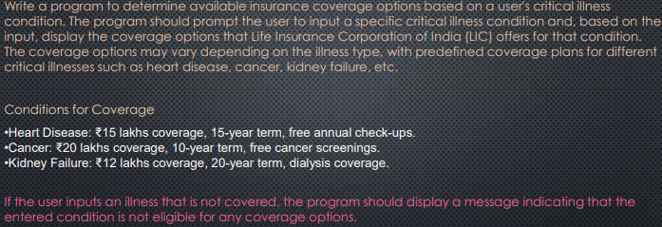

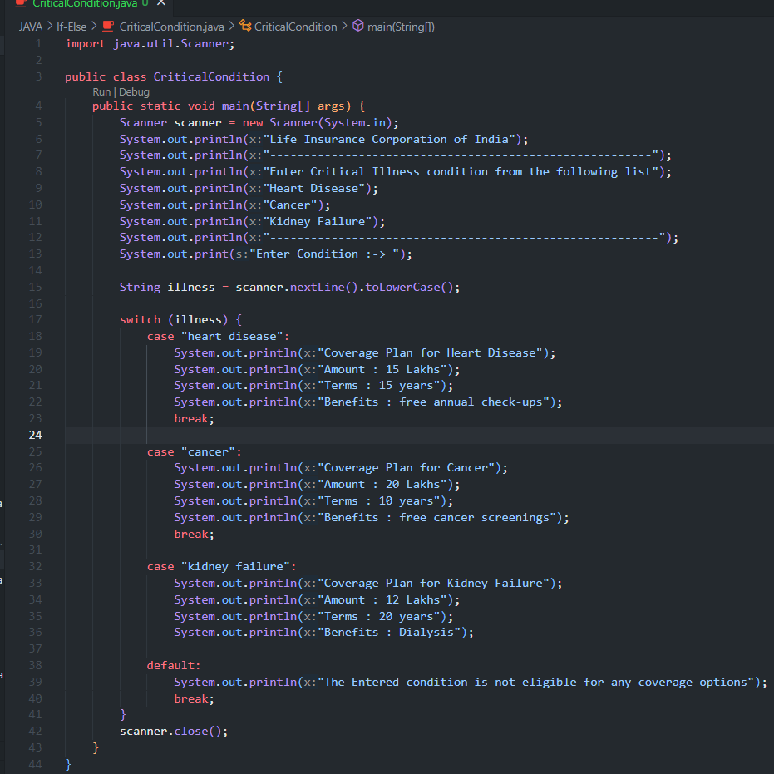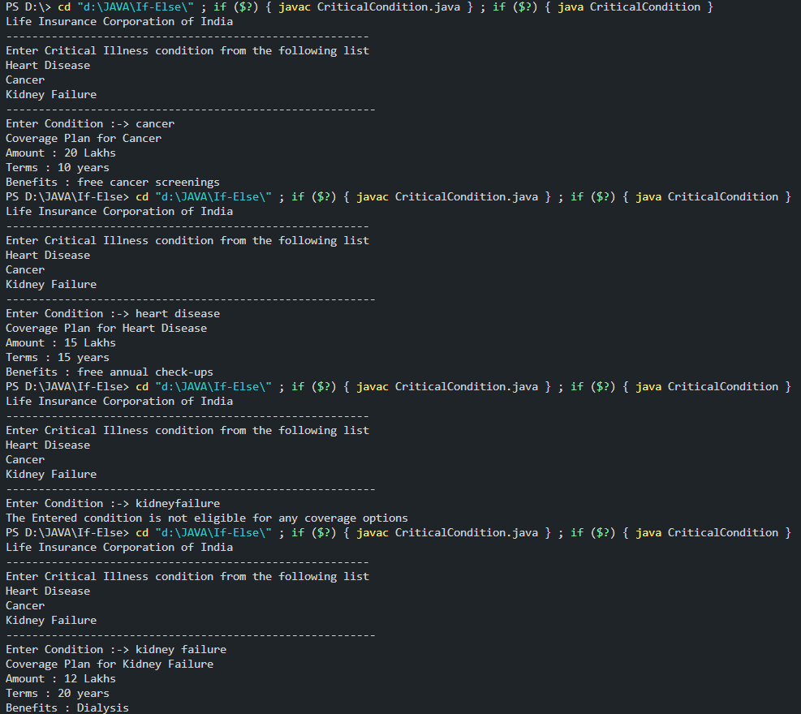

8>>>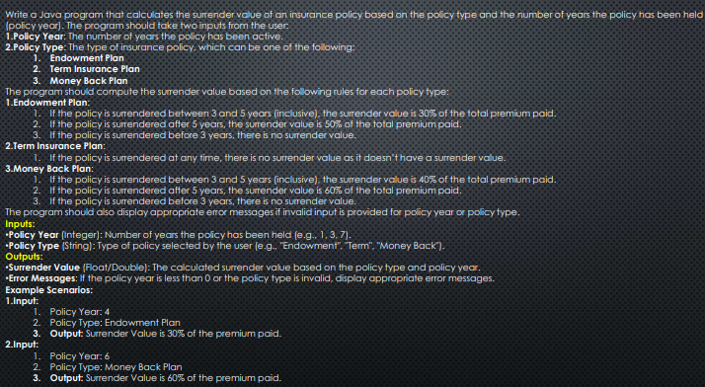

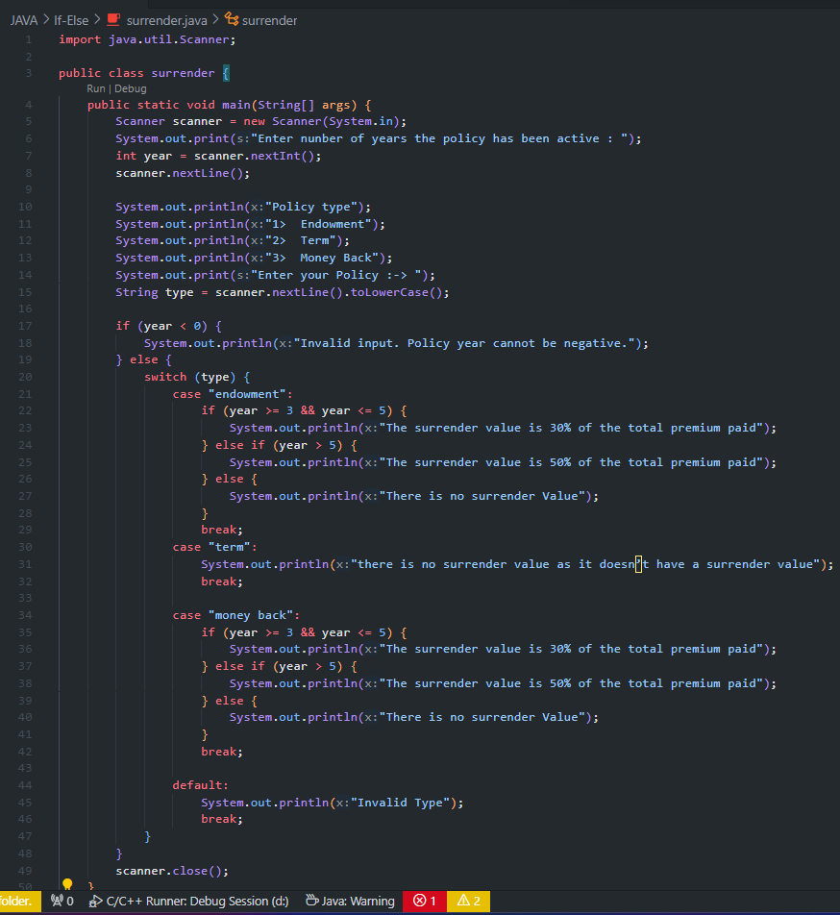

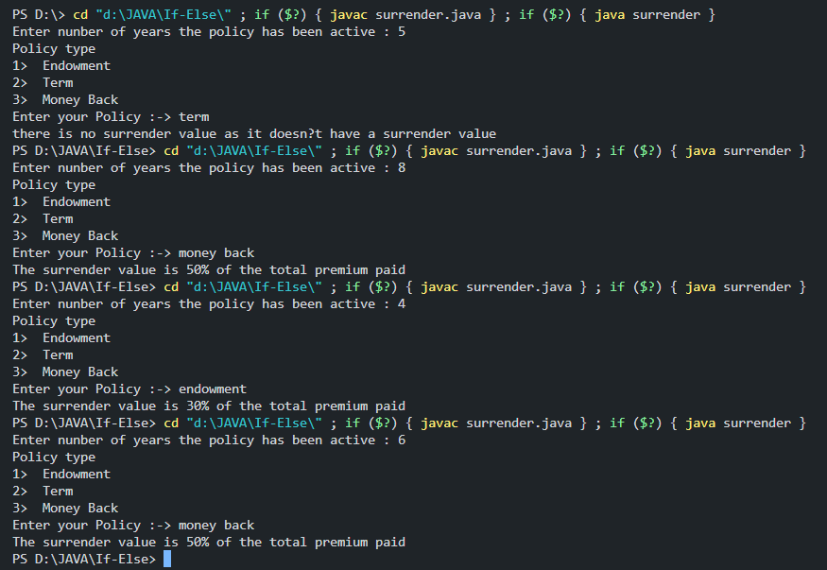

9>>>

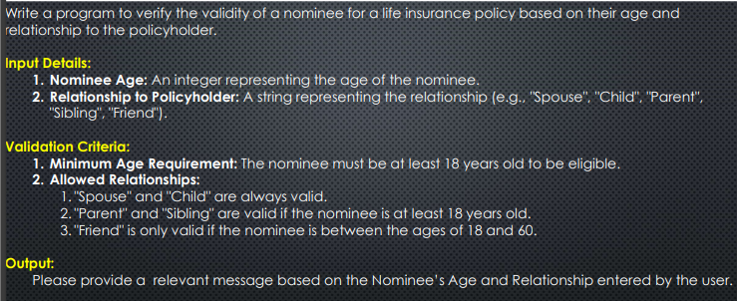

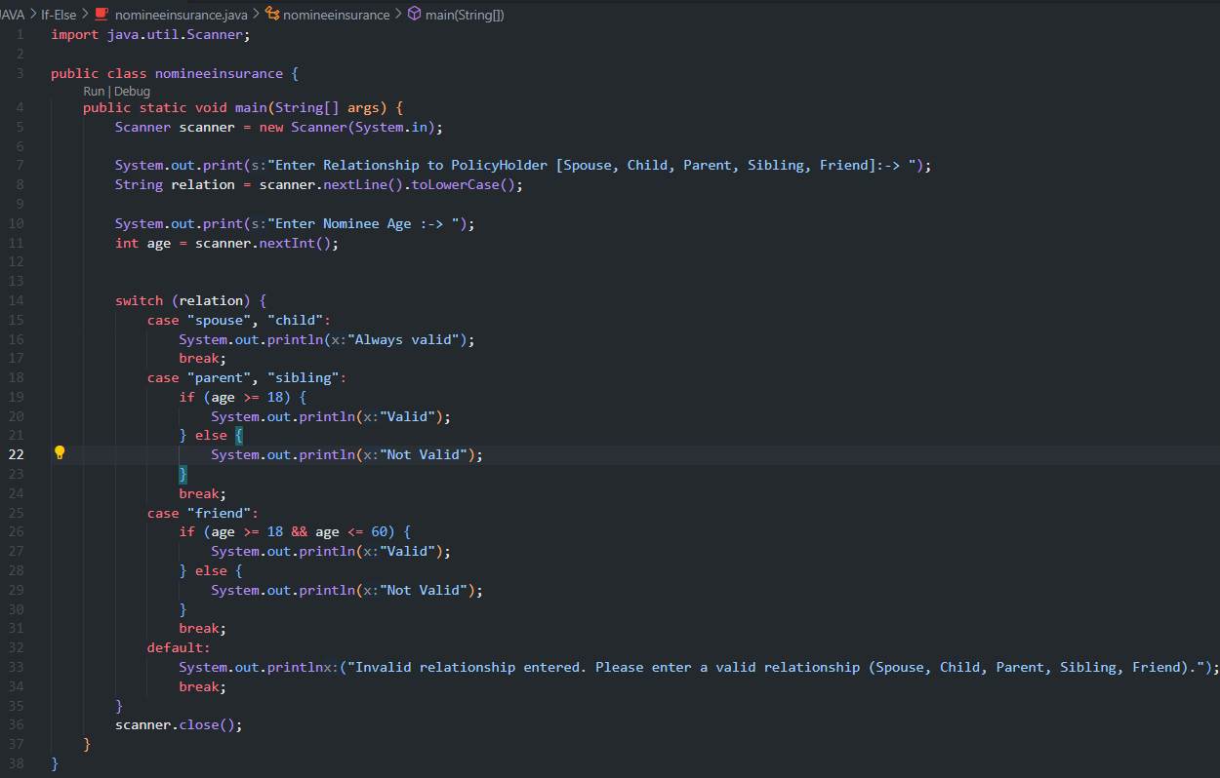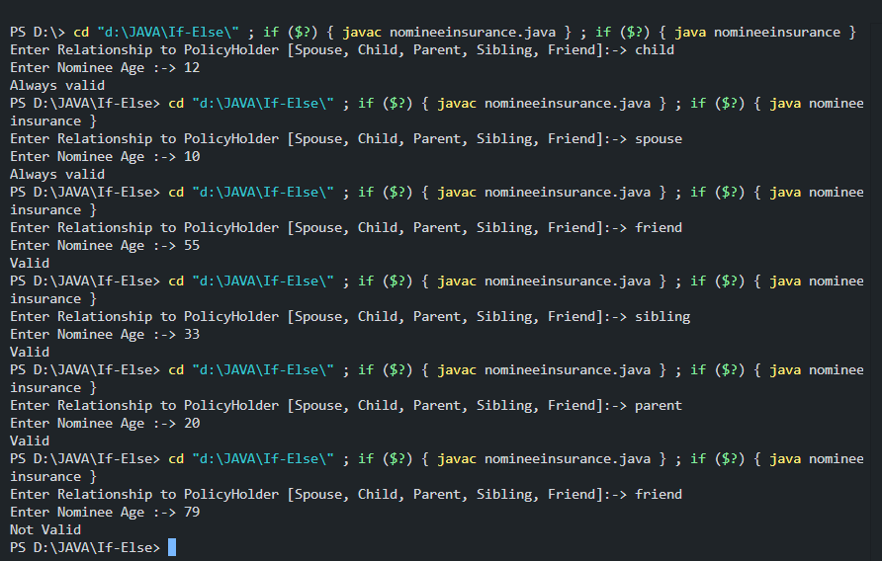

10>>>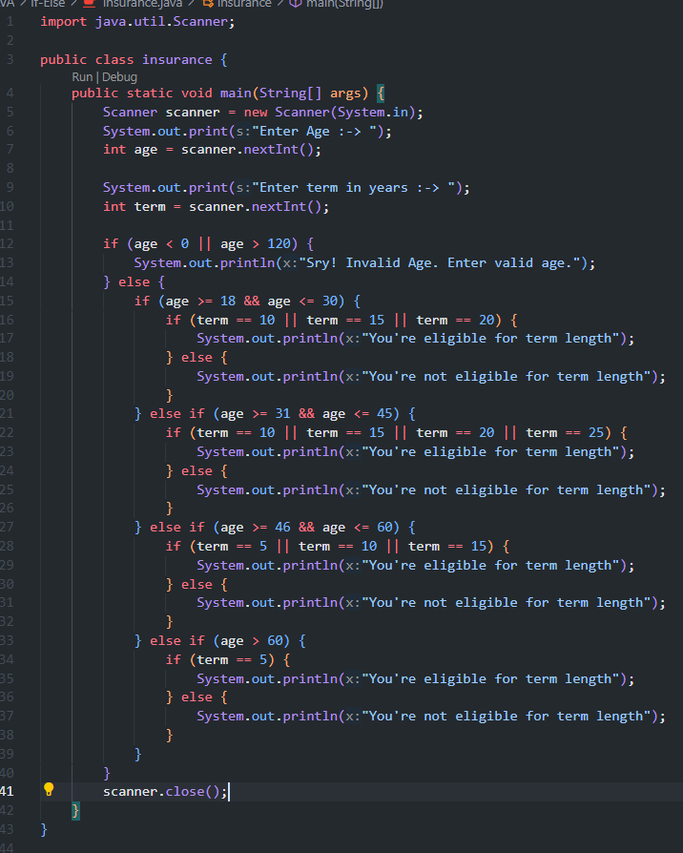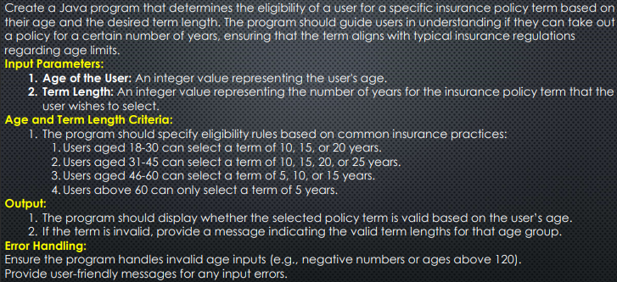

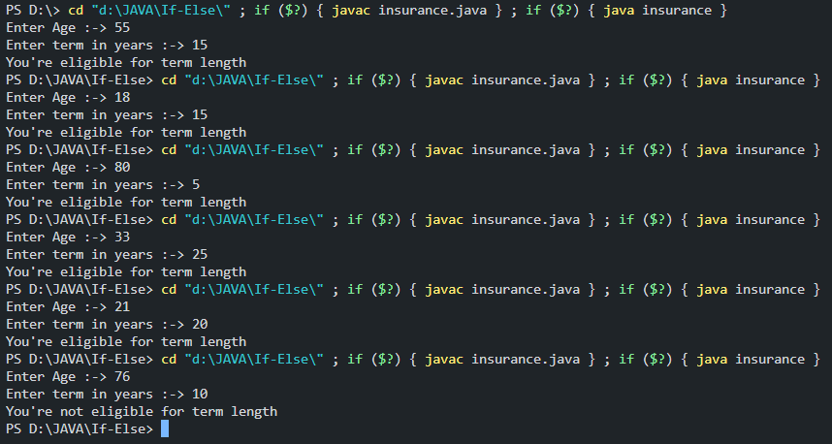

11>>>

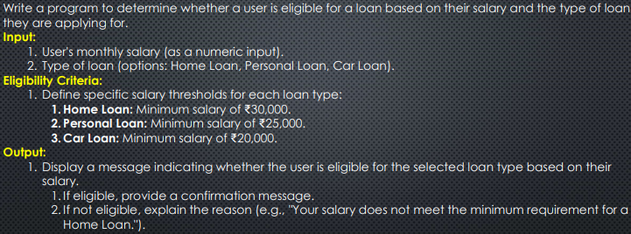

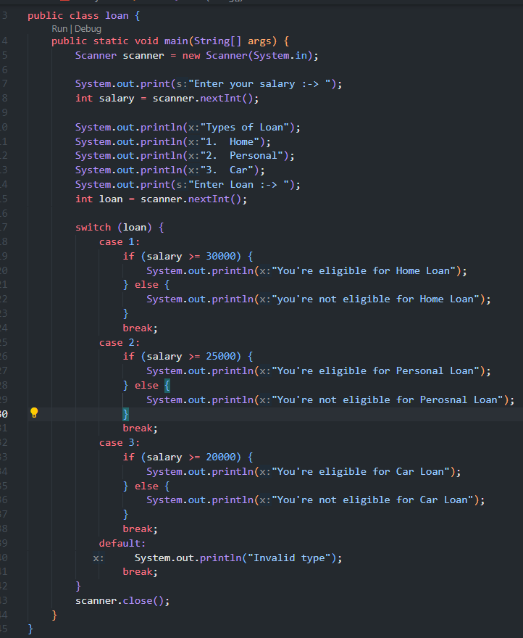

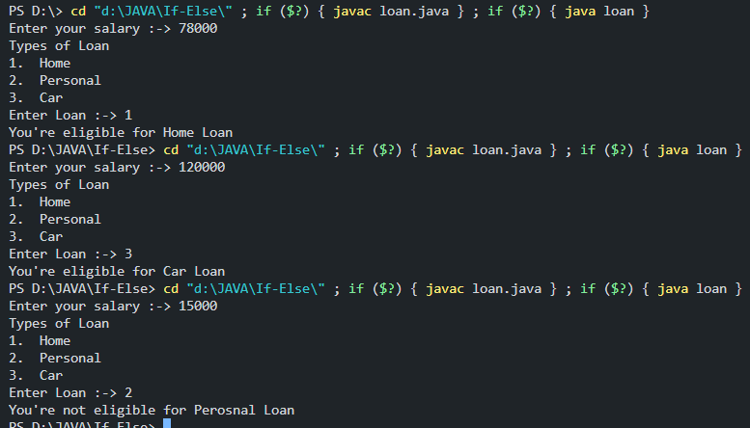

12>>>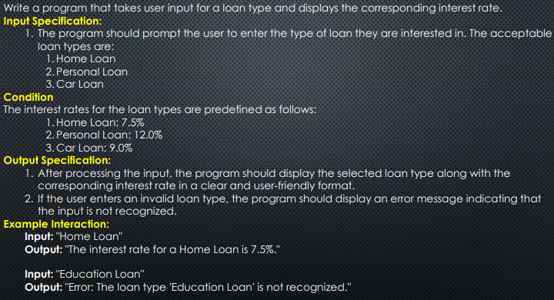

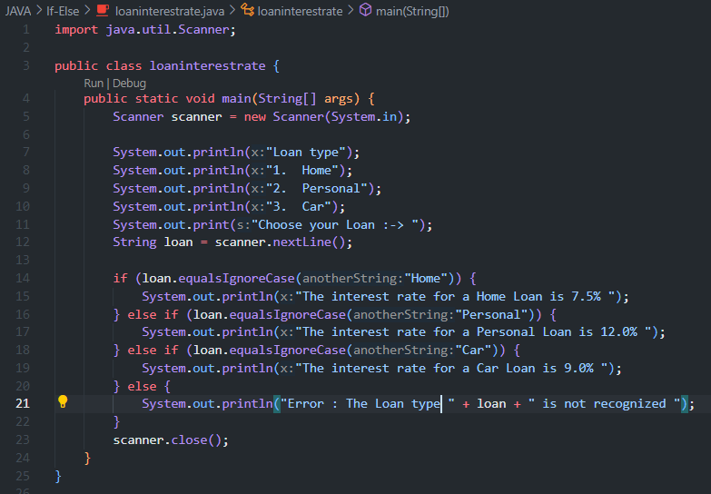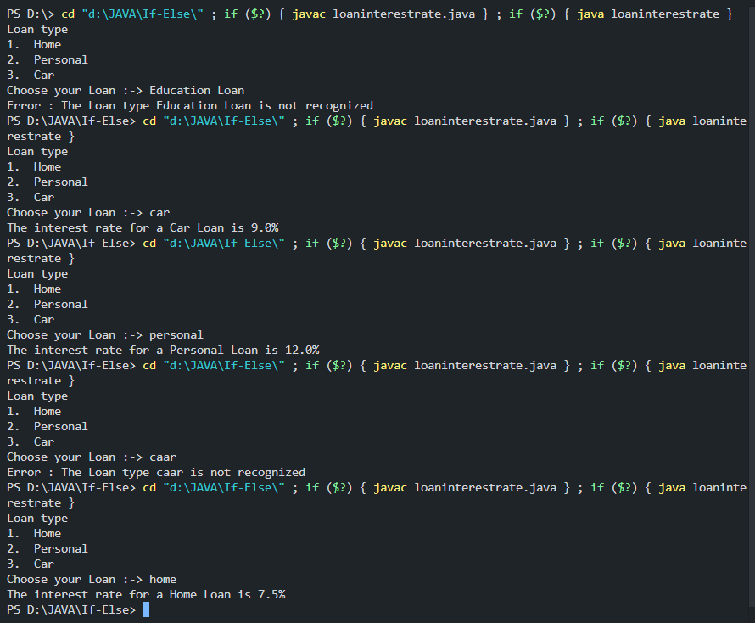

13>>>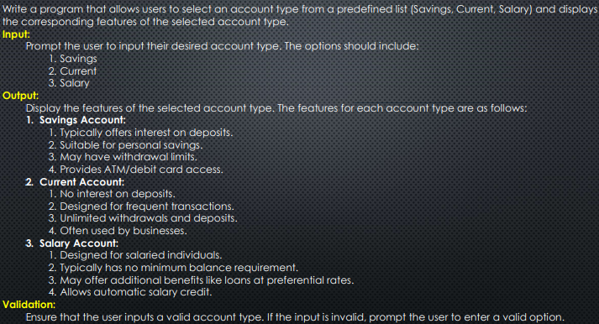

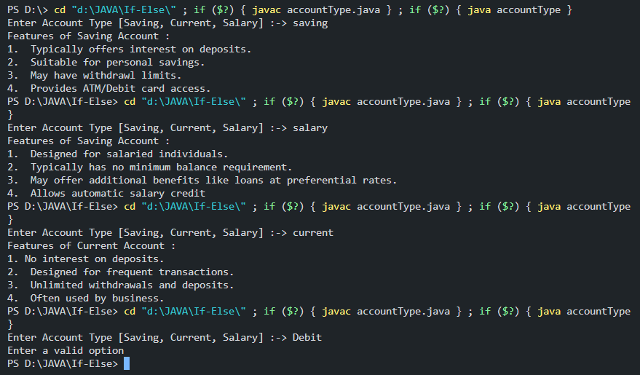

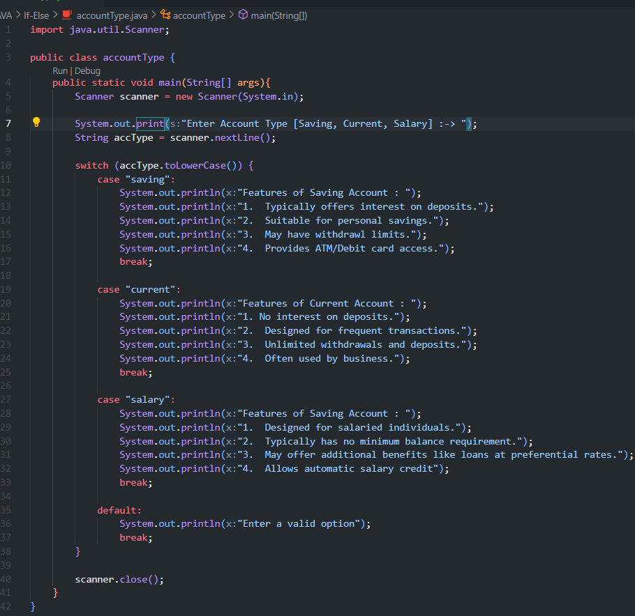

14>>>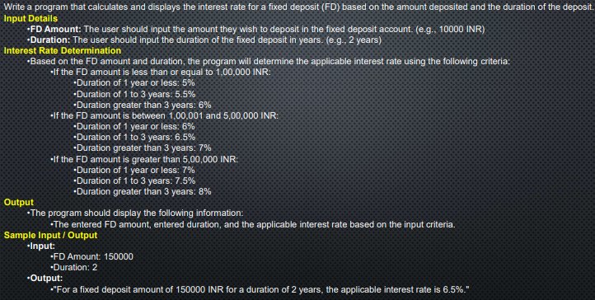

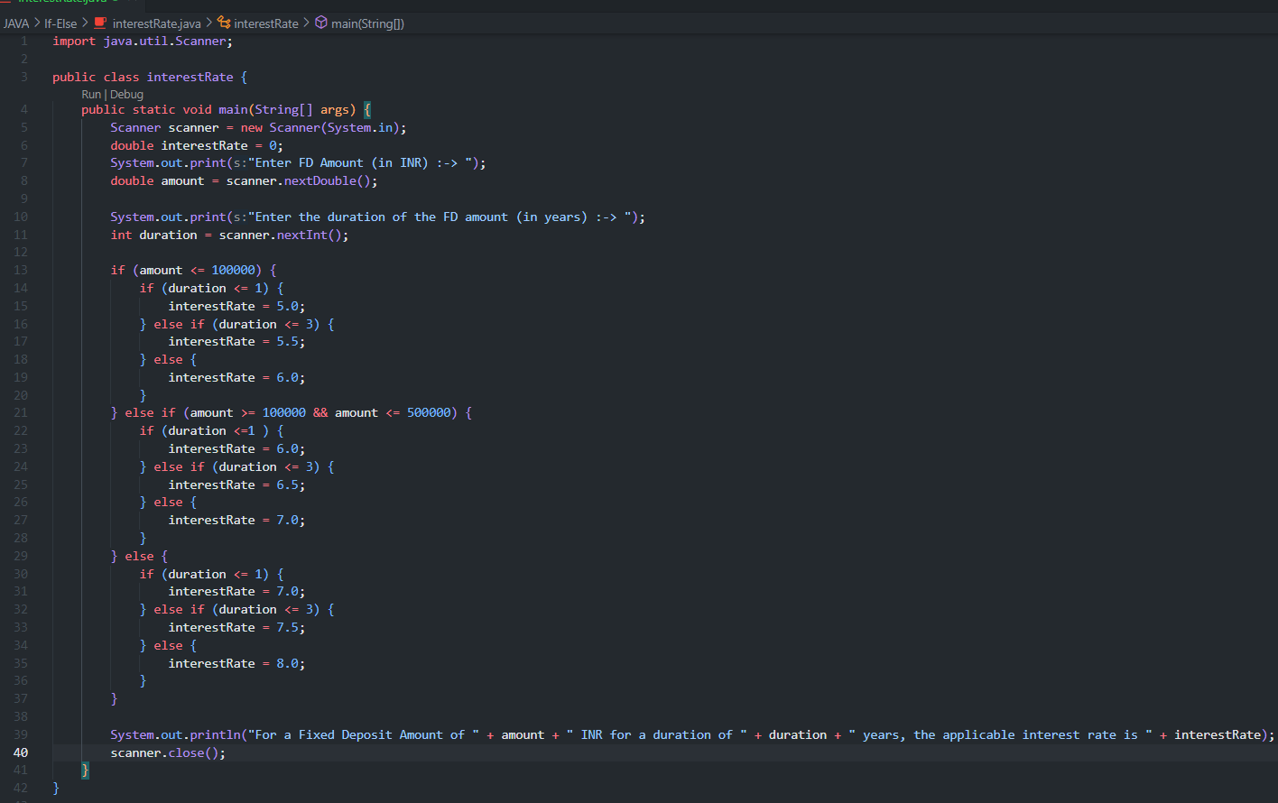

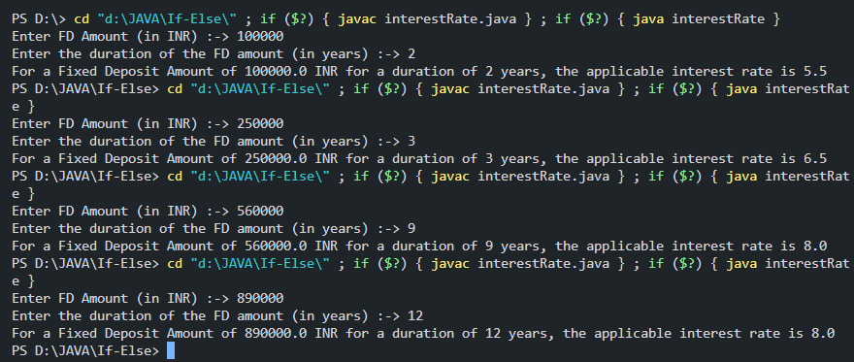

15>>>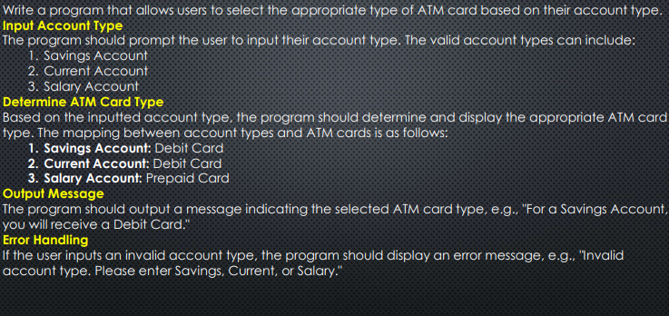

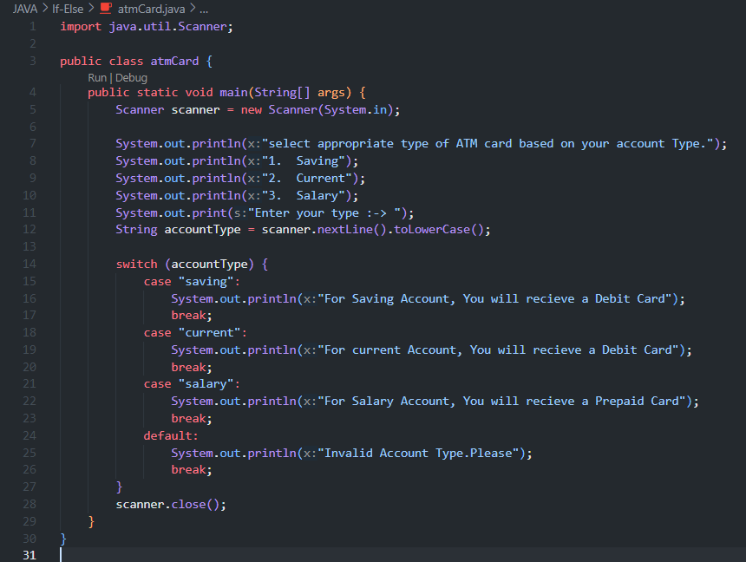

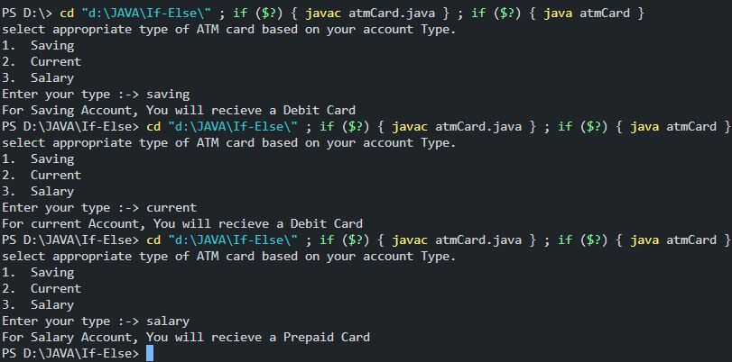

16>>>

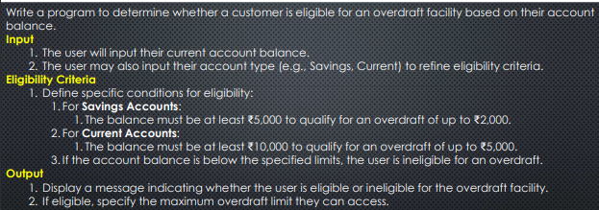

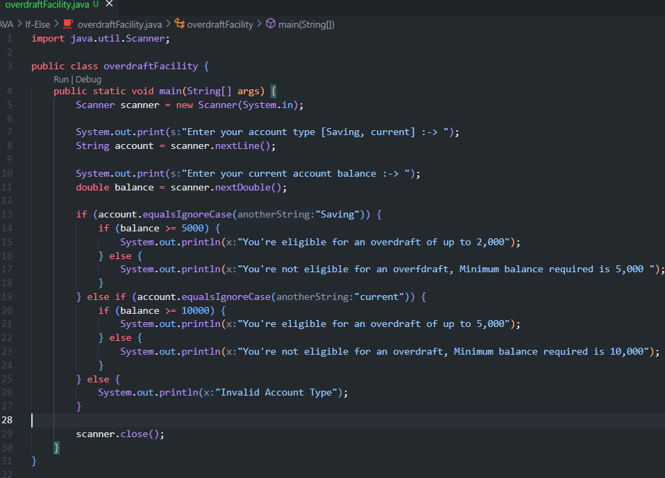

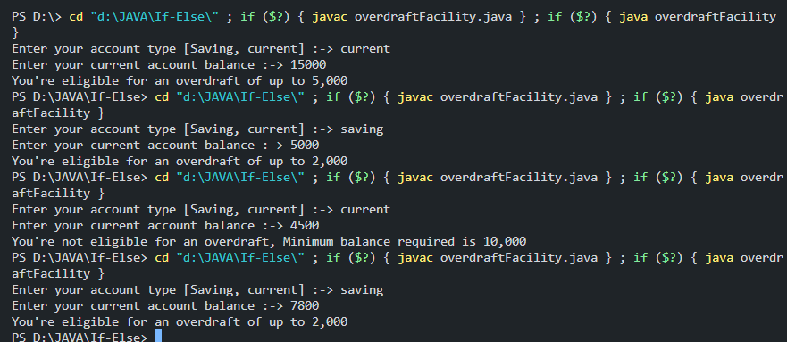

17>>>

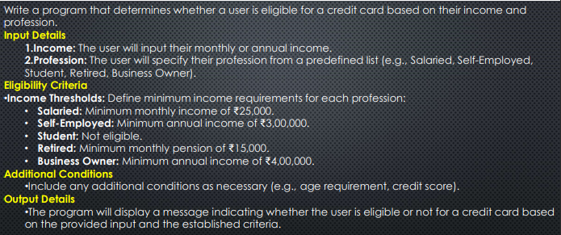

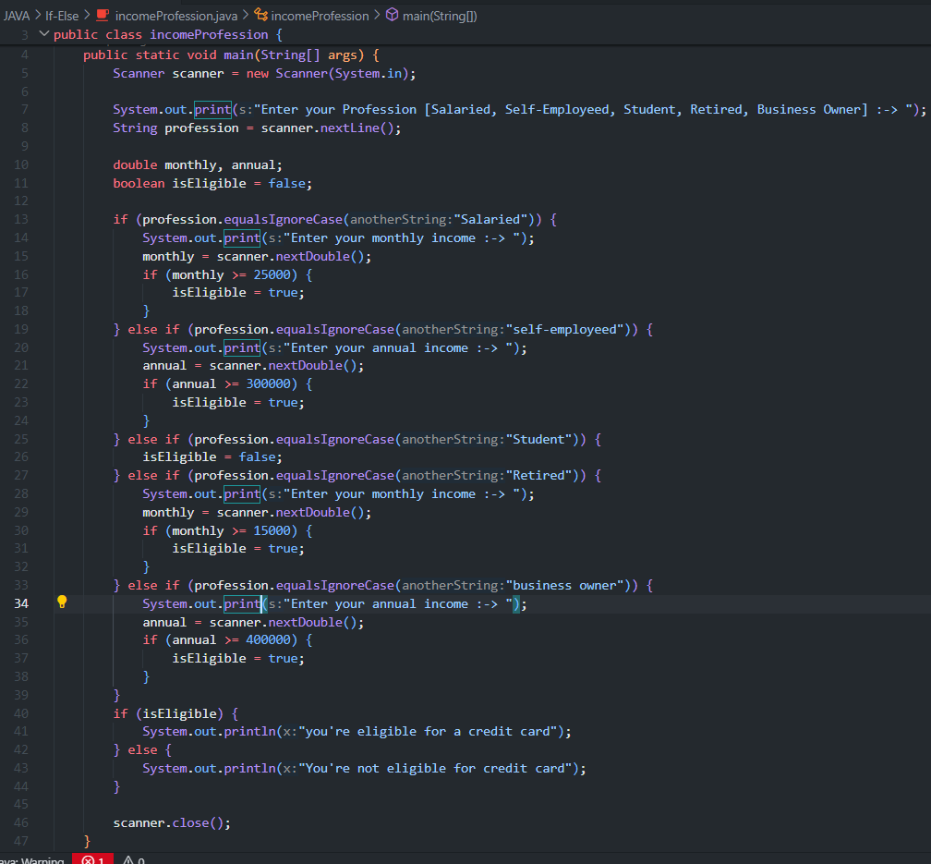

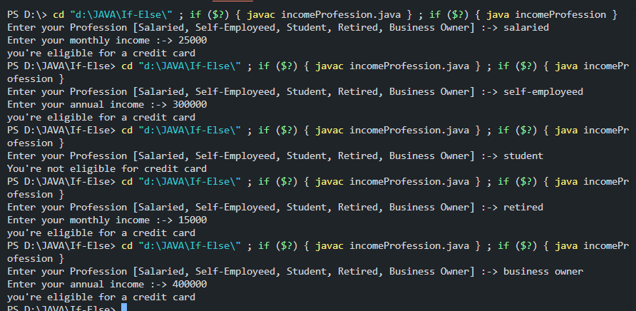

19>>>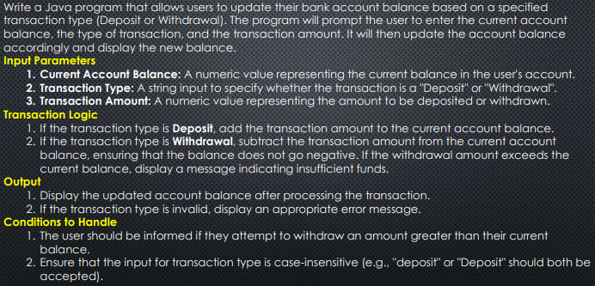

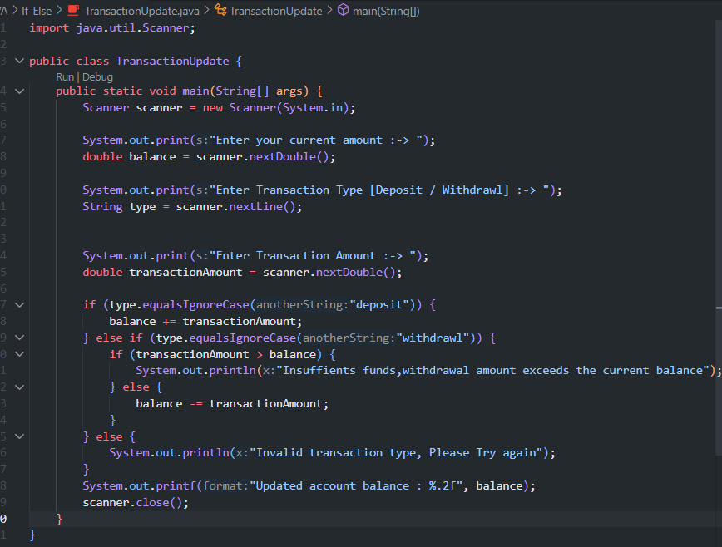

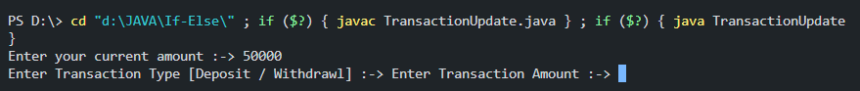

20>>>

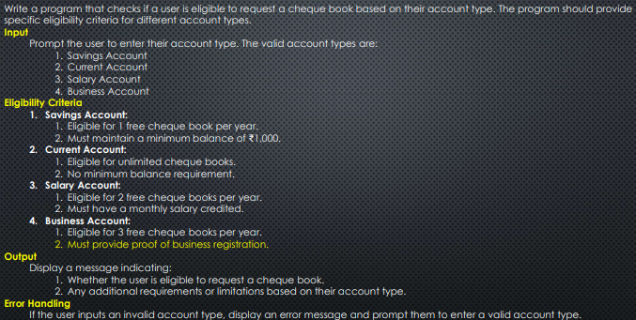

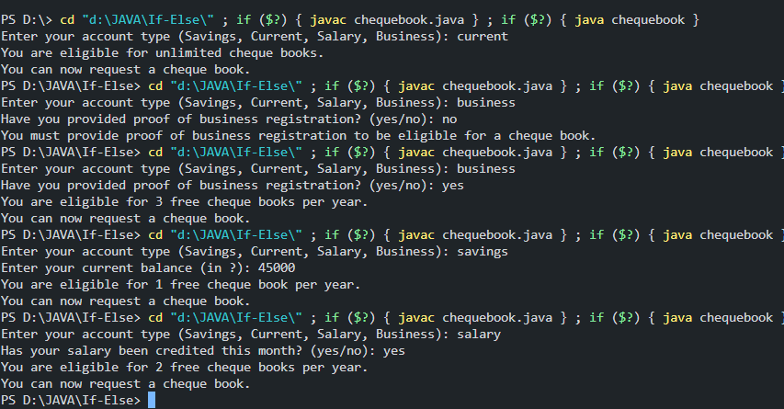

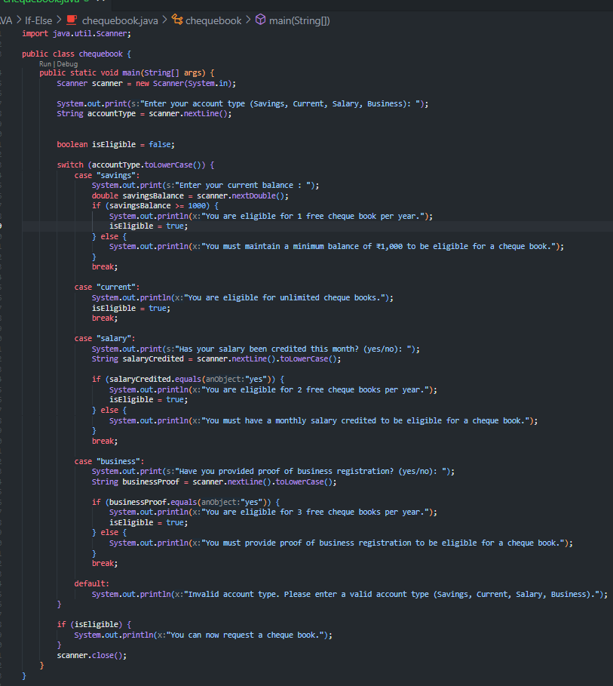

18>>>

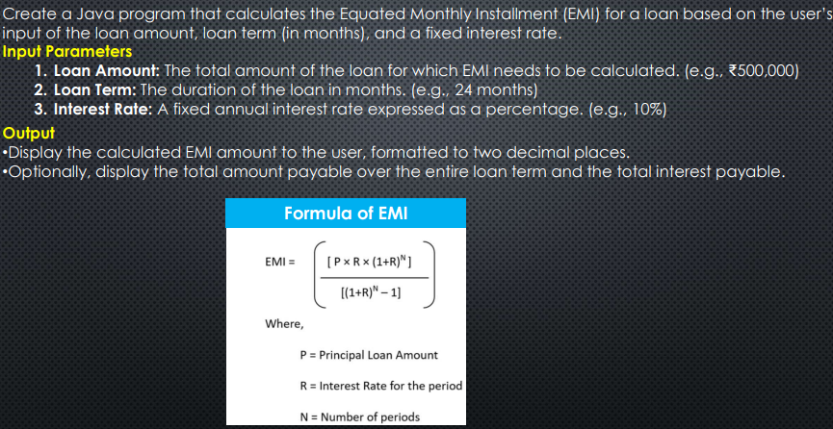

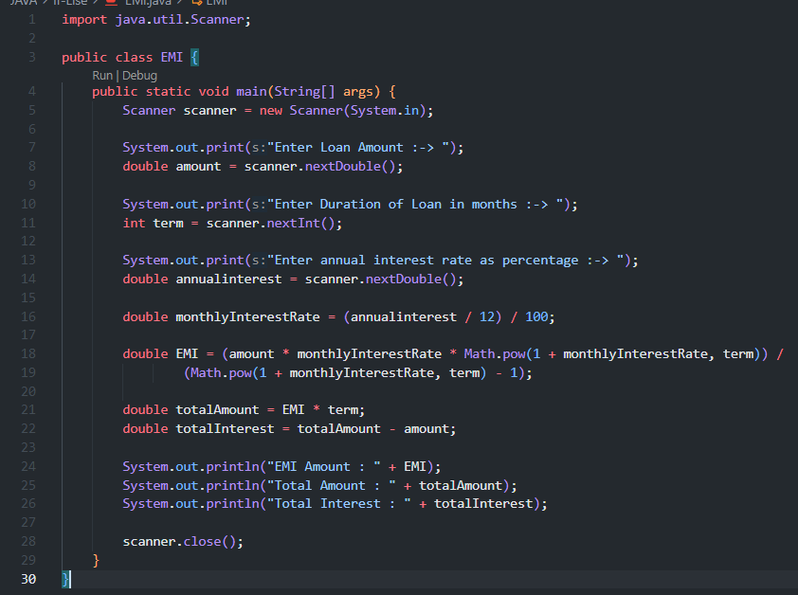

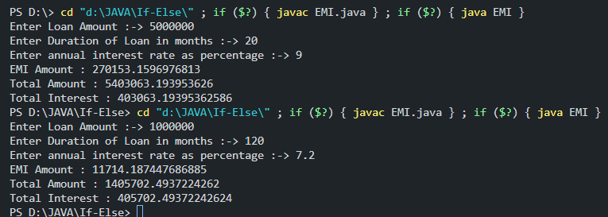

1>>>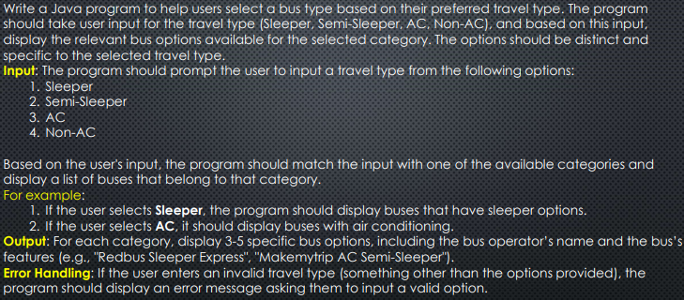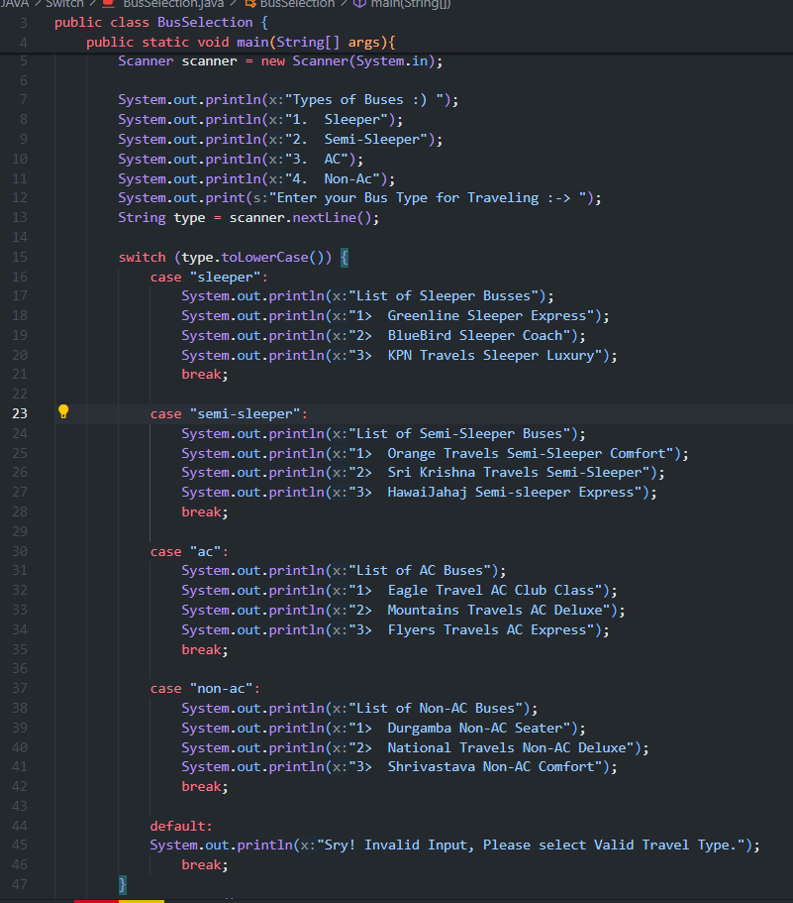

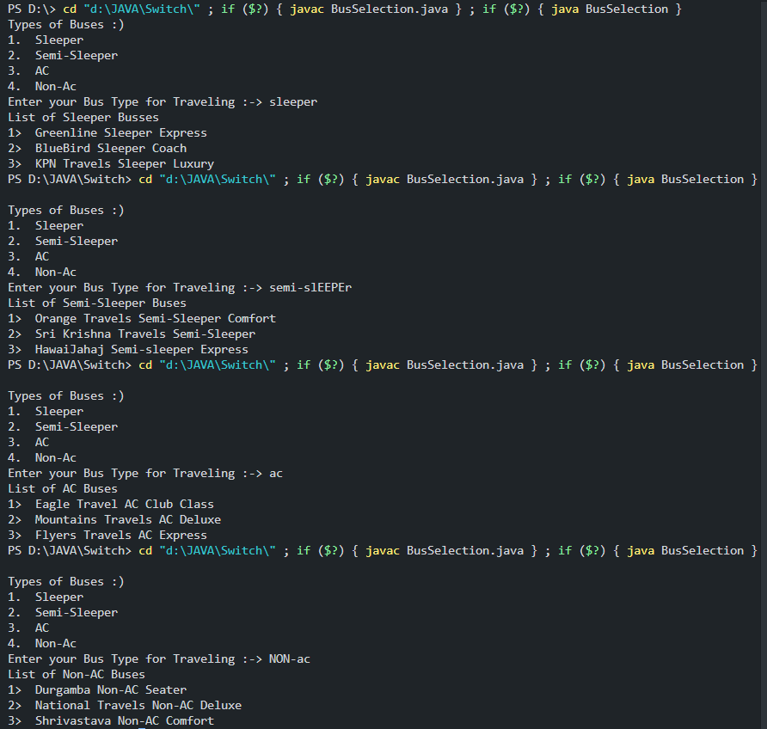

2>>>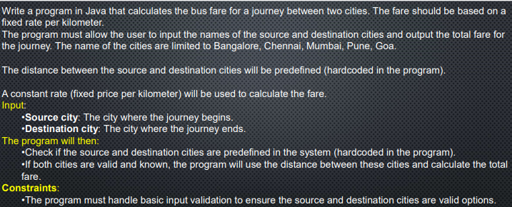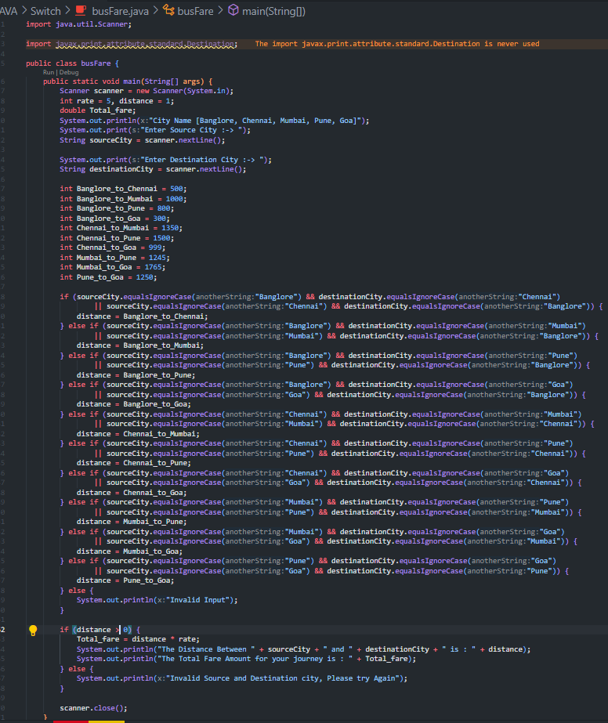

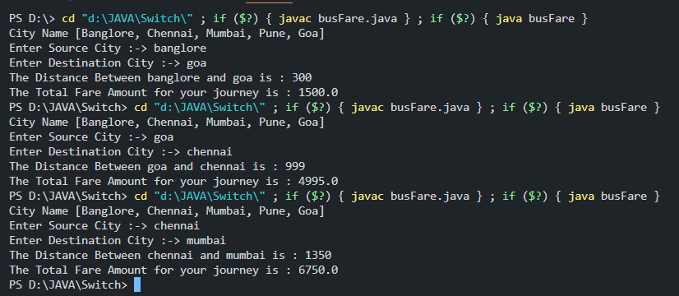

3>>>

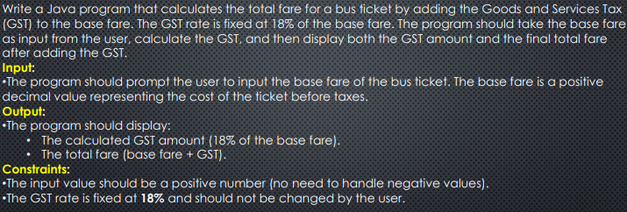

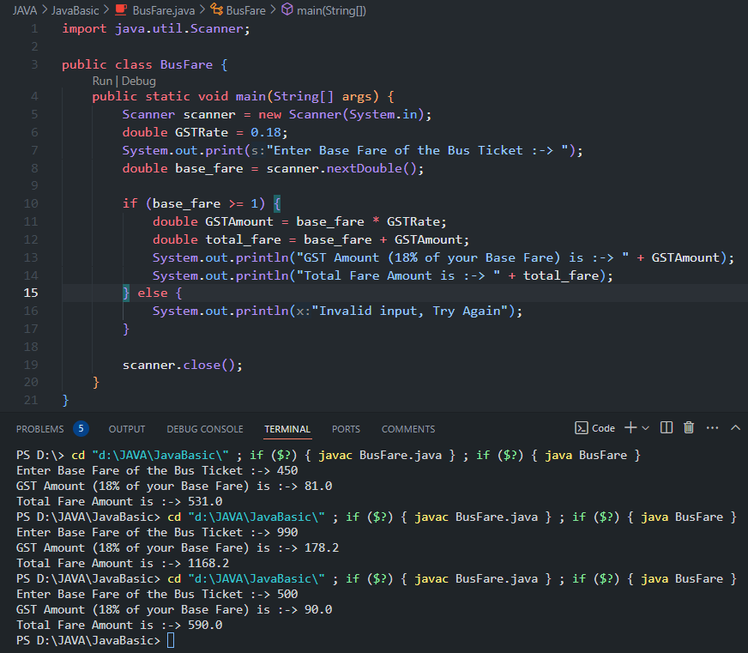

4>>>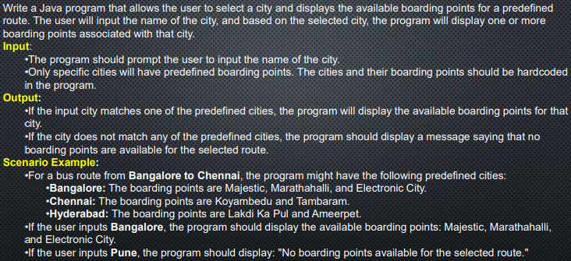

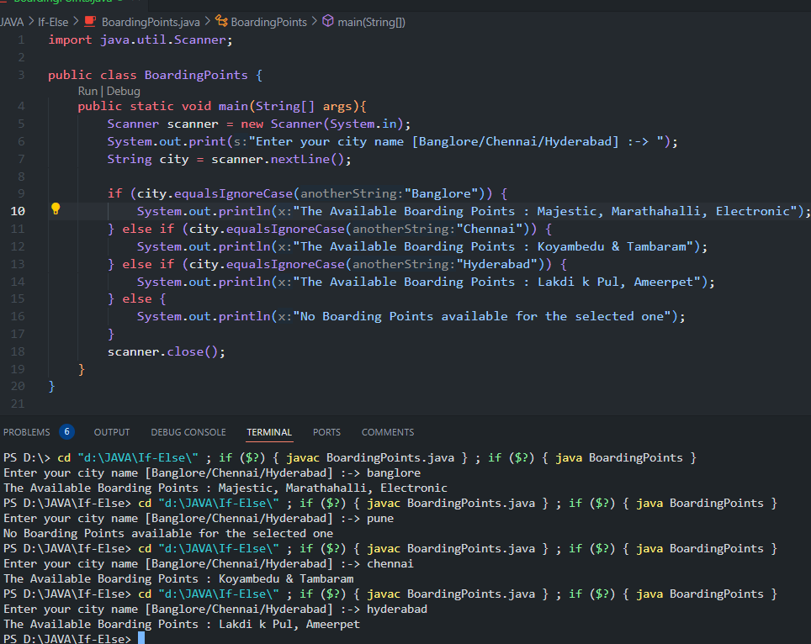

5>>>

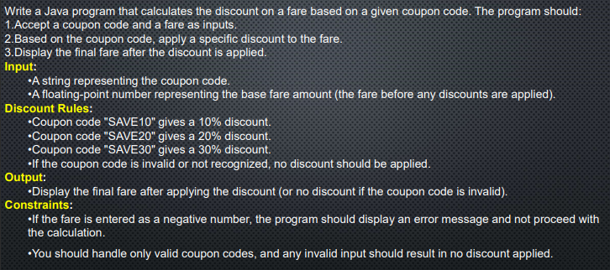

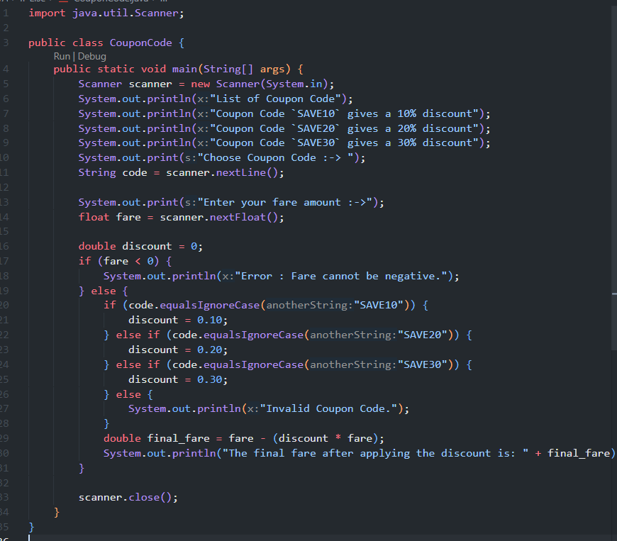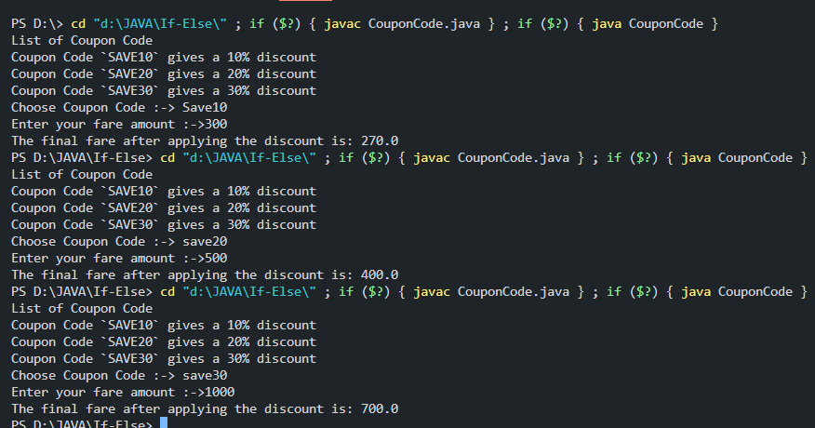

6>>>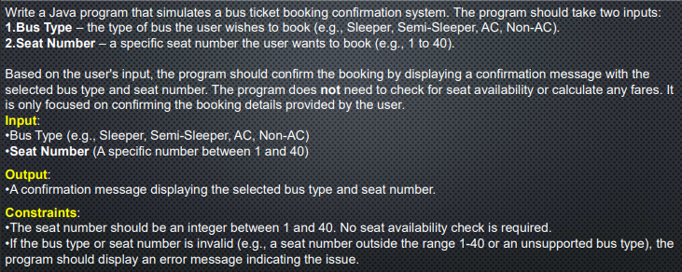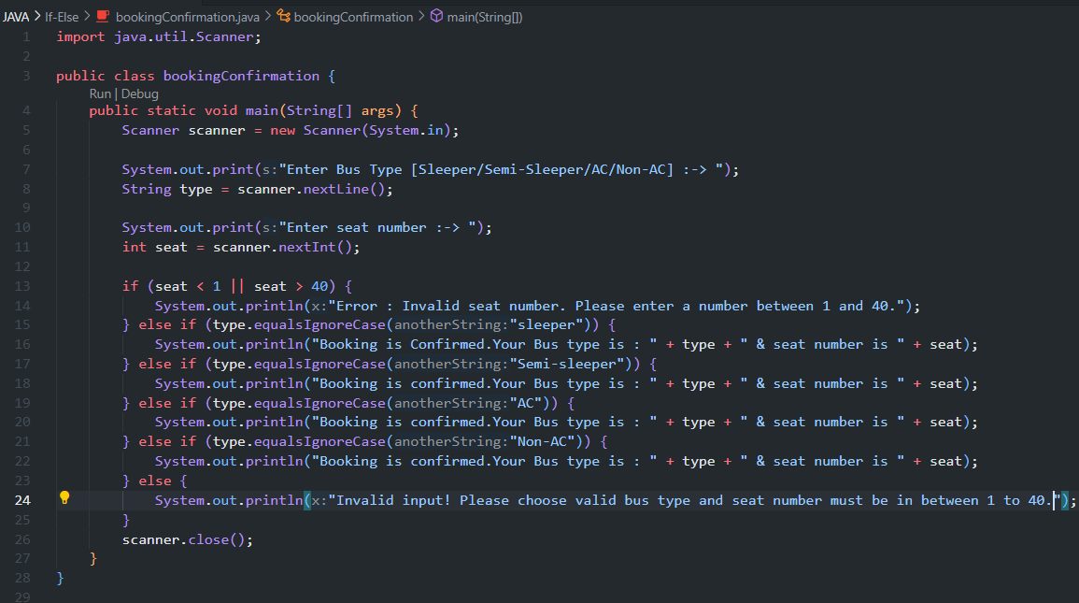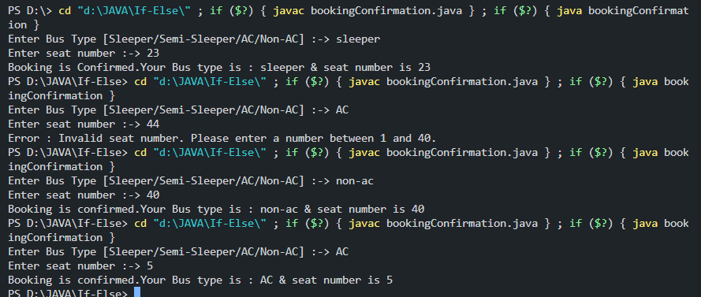

7>>>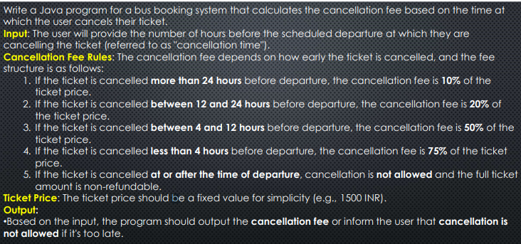

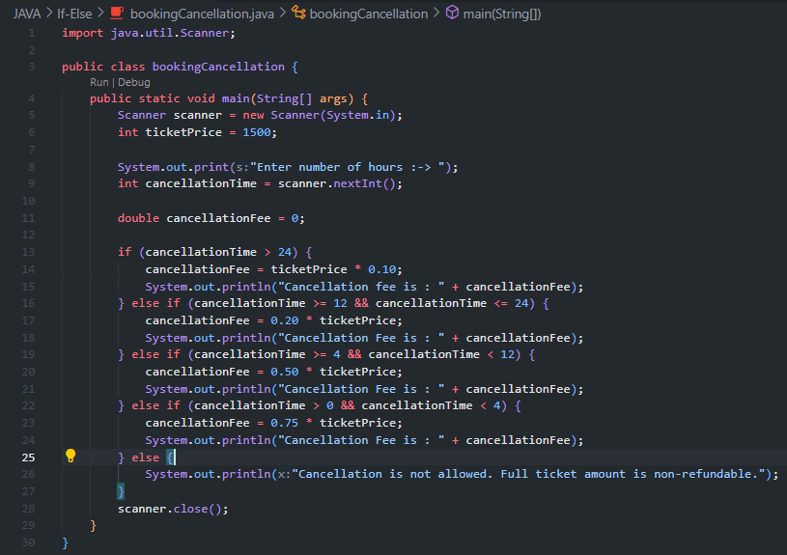

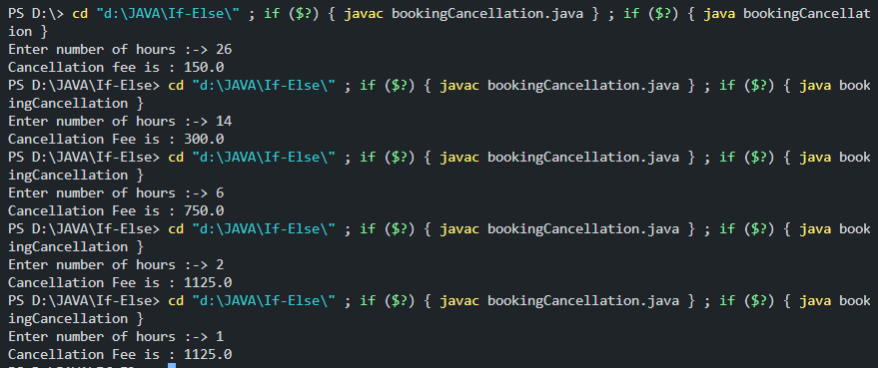

8>>>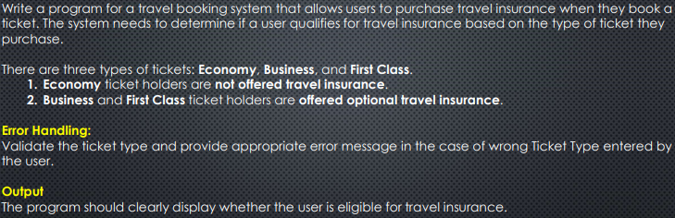

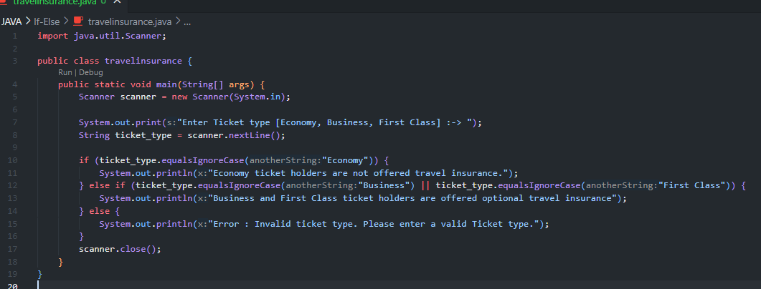

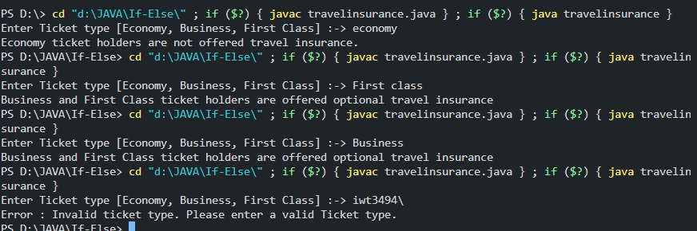

1>>>

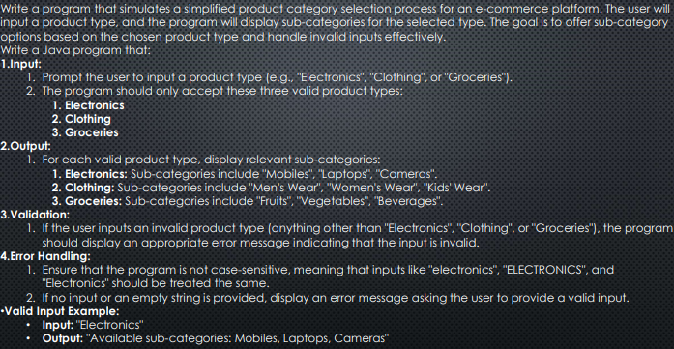import java.util.Scanner;

public class productCategories {

    public static void main(String[] args) {

        Scanner scanner = new Scanner(System.in);

        System.out.print("Enter a product Type [Electronics, Clothing, Groceries] :-> ");

        String prodType = scanner.nextLine();

        if (prodType.equals("")) {

            System.out.println("Error: Please enter a valid input");

        } else {

            if (prodType.equalsIgnoreCase("Electronics")) {

                System.out.println("Available Sub-Categories : Mobiles, Laptops, Cameras");

            } else if (prodType.equalsIgnoreCase("Clothing")) {

                System.out.println("Available Sub-Categories : Men's Wear, Women's Wear, Kid's Wear");

            } else if (prodType.equalsIgnoreCase("Groceries")) {

                System.out.println("Available Sub-Categories : Fruits, Vegetables, Beverages");

            } else {

                System.out.println("Invalid Product Type. Please Enter [Electronics, Clothing, Groceries]");

            }

        }

        scanner.close();

    }

}

Enter a product Type [Electronics, Clothing, Groceries] :-> clothing

Available Sub-Categories : Men's Wear, Women's Wear, Kid's Wear

Enter a product Type [Electronics, Clothing, Groceries] :-> Electronics

Available Sub-Categories : Mobiles, Laptops, Cameras

Enter a product Type [Electronics, Clothing, Groceries] :-> GRoceries

Available Sub-Categories : Fruits, Vegetables, Beverages

Enter a product Type [Electronics, Clothing, Groceries] :->

Error: Please enter a valid input

2>>>

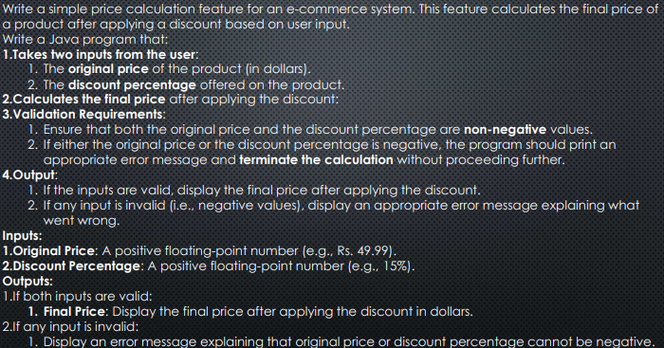

import java.util.Scanner;

public class finalprice {

    public static void main(String[] args) {

        Scanner scanner = new Scanner(System.in);

        System.out.print("Enter the Original price of product :-> ");

        double originalPrice = scanner.nextDouble();

        System.out.print("Enter the Discount :-> ");

        double discount = scanner.nextDouble();

        if (originalPrice < 0 || discount < 0) {

            System.out.println("Error: Original price and discount cannot be Negative.");

        } else {

            double discountAmount = (originalPrice \* discount) / 100;

            double finalprice = originalPrice - discountAmount;

            System.out.println("Final Price after applying the discount :-> " + finalprice);

        }

        scanner.close();

    }

}

Enter the Original price of product :-> -242

Enter the Discount :-> 823

Error: Original price and discount cannot be Negative.

Enter the Original price of product :-> 2000

Enter the Discount :-> 10

Final Price after applying the discount :-> 1800.0

Enter the Original price of product :-> 45000

Enter the Discount :-> -12

Error: Original price and discount cannot be Negative.

3>>>

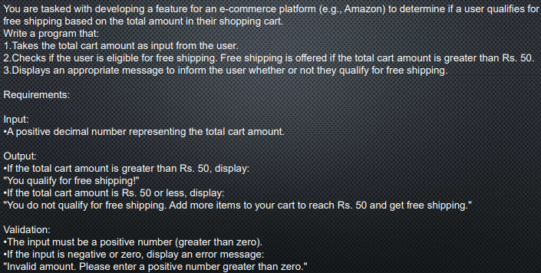

import java.util.Scanner;

public class carAmount {

    public static void main(String[] args) {

    Scanner scanner = new Scanner(System.in);

    System.out.print("Enter Total Car Amount (in Rs) :-> ");

    double totalAmount = scanner.nextDouble();

    if (totalAmount <= 0) {

        System.out.println("Invalid Amount, Please enter positive number.");

    } else if (totalAmount > 50) {

        System.out.println("You qualify for free shipping!");

    } else {

        System.out.println("You do not qualify for free shipping. Add more items to your cart to reach Rs. 50 and get free shipping");

    }

    scanner.close();

    }

}

Enter Total Car Amount (in Rs) :-> 50000

You qualify for free shipping!

Enter Total Car Amount (in Rs) :-> 50

You do not qualify for free shipping. Add more items to your cart to reach Rs. 50 and get free shipping.

Enter Total Car Amount (in Rs) :-> -34534353

Invalid Amount, Please enter positive number.

4>>>

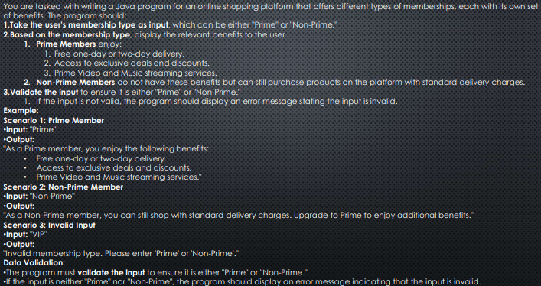import java.util.Scanner;

public class membersShip {

    public static void main(String[] args) {

        Scanner scanner = new Scanner(System.in);

        System.out.print("Enter your MemebrShip Type [Prime/Non-Prime] :-> ");

        String memberType = scanner.nextLine();

        if (memberType.equalsIgnoreCase("Prime")) {

            System.out.println("As a Prime member, you enjoy the following benefits:");

            System.out.println("> Free one-day or two-day delivery.");

            System.out.println("> Access to exclusive deals and discounts");

            System.out.println("> Prime Video and Music Streaming Services.");

        } else if (memberType.equalsIgnoreCase("Non-Prime")) {

            System.out.println("As a Non-Prime member, You can still shop with standard delivery charges.");

            System.out.println("Upgrade to prime to enjoy additional benefits.");

        } else {

            System.out.println("Invalid membership type. Please enter [Prime/Non-Prime]");

        }

        scanner.close();

    }

}

Enter your MemebrShip Type [Prime/Non-Prime] :-> ingwf

Invalid membership type. Please enter [Prime/Non-Prime]

Enter your MemebrShip Type [Prime/Non-Prime] :-> prime

As a Prime member, you enjoy the following benefits:

> Free one-day or two-day delivery.

> Access to exclusive deals and discounts

> Prime Video and Music Streaming Services.

Enter your MemebrShip Type [Prime/Non-Prime] :-> non-prime

As a Non-Prime member, You can still shop with standard delivery charges.

Upgrade to prime to enjoy additional benefits.

5>>>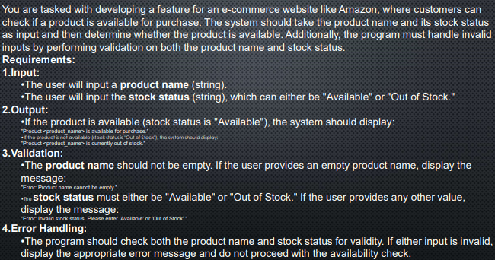

import java.util.Scanner;

public class productavailableforpurchase {

    public static void main(String[] args) {

        Scanner scanner = new Scanner(System.in);

        System.out.print("Enter a product name :-> ");

        String productName = scanner.nextLine();

        if (productName.equals(" ")) {

            System.out.println("Error : Product name cannot be empty");

        }

        System.out.print("Enter stock status [Available / Out of stock] :-> ");

        String stockStatus = scanner.nextLine();

        if (!stockStatus.equalsIgnoreCase("Available") && !stockStatus.equalsIgnoreCase("Out of stock")) {

            System.out.println("Error : Invalid Stock status, Please enter [Available / Out of Stock]");

        } else if (stockStatus.equalsIgnoreCase("Available")) {

            System.out.println("Product : " + productName + " is available for purchase");

        } else {

            System.out.println("Product : " + productName + " is Currently out of stock");

        }

        scanner.close();

    }

}

Enter a product name :-> tv

Enter stock status [Available / Out of stock] :-> available

Product : tv is available for purchase

Enter a product name :-> phone

Enter stock status [Available / Out of stock] :-> out of stock

Product : phone is Currently out of stock

Enter a product name :->

Error : Product name cannot be empty

6>>>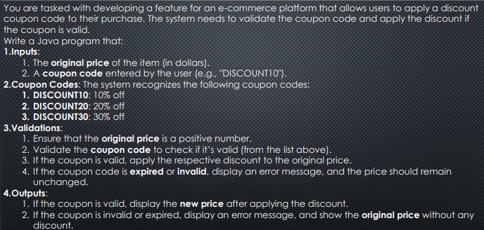

import java.util.Scanner;

public class discountCoupon {

    public static void main(String[] args) {

        Scanner scanner = new Scanner(System.in);

        System.out.print("Enter original price of the item [in dollars] :-> ");

        double originalPrice = scanner.nextDouble();

        scanner.nextLine();

        if (originalPrice <= 0) {

            System.out.println("Error: The original price must be a positive");

        }

        System.out.print("Enter Coupon Code :-> ");

        String couponCode = scanner.nextLine();

        double finalPrice = originalPrice;

        switch (couponCode.toUpperCase()) {

            case "DISCOUNT10":

                finalPrice = originalPrice \* 0.90;

                System.out.println("New Price = " + finalPrice);

                break;

            case "DISCOUNT20":

                finalPrice = originalPrice \* 0.80;

                System.out.println("New Price = " + finalPrice);

                break;

            case "DISCOUNT30":

                finalPrice = originalPrice \* 0.70;

                System.out.println("New Price = " + finalPrice);

                break;

            default:

                System.out.println("Sry! Invalid or Expired Coupon Code. No Discount applied");

                break;

        }

        scanner.close();

    }

}

Enter original price of the item [in dollars] :-> 100

Enter Coupon Code :-> discount10

New Price = 90.0

Enter original price of the item [in dollars] :-> 100

Enter Coupon Code :-> discount20

New Price = 80.0

Enter original price of the item [in dollars] :-> 100

Enter Coupon Code :-> discount30

New Price = 70.0

Enter original price of the item [in dollars] :-> 999

Enter Coupon Code :-> discount30

New Price = 699.3

Enter original price of the item [in dollars] :-> -78

Error: The original price must be a positive

Enter original price of the item [in dollars] :-> 4566

Enter Coupon Code :-> discount50

Sry! Invalid or Expired Coupon Code. No Discount applied

7>>>

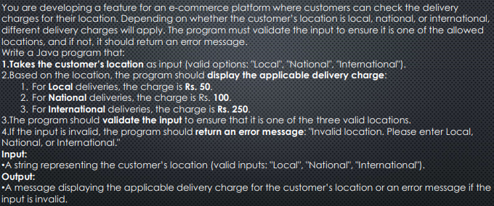import java.util.Scanner;

public class LocationCharges {

    public static void main(String[] args) {

        Scanner scanner = new Scanner(System.in);

        System.out.print("Enter your location [Local, National, InterNational] :-> ");

        String location = scanner.nextLine();

        double deliveryCharge = 0;

        switch (location.toLowerCase()) {

            case "Local":

                deliveryCharge = 50.0;

                System.out.println("For Local Deliveries, the charge is " + deliveryCharge);

                break;

            case "National":

                System.out.println("For Naitonal Deliveries, the charge is " + deliveryCharge);

                break;

            case "InterNational":

                System.out.println("For InterNational Deliveries, the charge is " + deliveryCharge);

                break;

            default:

                System.out.println("Invalid Location. Please Enter [Local, Naitonal, InterNational]");

                break;

        }

        scanner.close();

    }

}

Enter your location [Local, National, InterNational] :-> national

For Naitonal Deliveries, the charge is 100.0

Enter your location [Local, National, InterNational] :-> local

For Local Deliveries, the charge is 50.0

Enter your location [Local, National, InterNational] :-> international

For InterNational Deliveries, the charge is 250.0

Enter your location [Local, National, InterNational] :-> internaitonal

Invalid Location. Please Enter [Local, Naitonal, InterNational]

8>>>

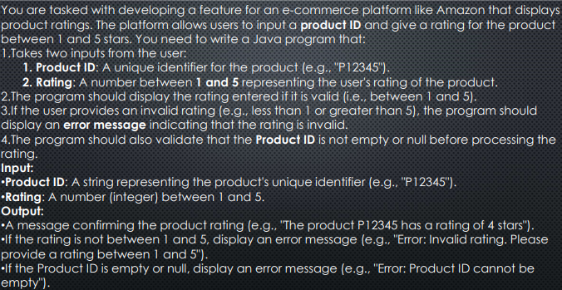

import java.util.Scanner;

public class ProductRating {

    public static void main(String[] args) {

    Scanner scanner = new Scanner(System.in);

    System.out.print("Enter Product ID :-> ");

    String productID = scanner.nextLine();

    if (productID.isEmpty()) {

        System.out.println("Error : ProductID cannot be empty");

    } else {

        System.out.print("Enter product rating ( 1 to 5 stars) :-> ");

        int rating = scanner.nextInt();

        if (rating < 1 || rating > 5) {

            System.out.println("Error : Invalid rating. Please enter rating between 1 and 5");

        } else {

            System.out.println("The product " + productID + " has a rating of " + rating + "stars");

        }

    }

    scanner.close();

    }

}

Enter Product ID :-> atwe242

Enter product rating ( 1 to 5 stars) :-> 1

The product atwe242 has a rating of 1stars

Enter Product ID :-> 23424

Enter product rating ( 1 to 5 stars) :-> 3

The product 23424 has a rating of 3stars

Enter Product ID :->

Error : ProductID cannot be empty

9>>>

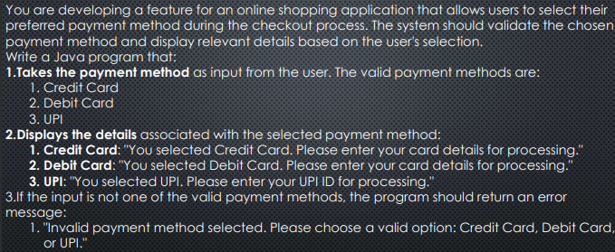

import java.util.Scanner;

public class paymentMethod {

    public static void main(String[] args) {

        Scanner scanner = new Scanner(System.in);

        System.out.print("Enter Payment Method [Credit card/Debit Card/ UPI] :-> ");

        String paymentMethod = scanner.nextLine();

        switch (paymentMethod) {

            case "Credit card":

                System.out.println("You selected Credit Card. Please enter your card details for processing");

                break;

            case "Debit Card":

                System.out.println("You selected Debit Card. Please enter your card details for processing");

                break;

            case "UPI":

                System.out.println("You selected UPI. Please enter your UPI ID for processing");

                break;

            default:

                System.out.println(

                        "Invalid payment method selected. Please choose a valid option: Credit Card, Debit Card or UPI.");

                break;

        }

        scanner.close();

    }

}

Enter Payment Method [Credit card/Debit Card/ UPI] :-> Debit Card

You selected Debit Card. Please enter your card details for processing

Enter Payment Method [Credit card/Debit Card/ UPI] :-> Credit card

You selected Credit Card. Please enter your card details for processing

Enter Payment Method [Credit card/Debit Card/ UPI] :-> UPI

You selected UPI. Please enter your UPI ID for processing

Enter Payment Method [Credit card/Debit Card/ UPI] :-> Credit Card

Invalid payment method selected. Please choose a valid option: Credit Card, Debit Card or UPI.

10>>>

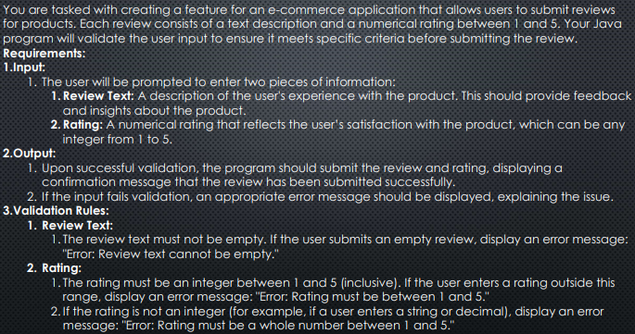

import java.util.Scanner;

public class reviewofproducts {

    public static void main(String[] args) {

        Scanner scanner = new Scanner(System.in);

        System.out.print("Enter your review :-> ");

        String reviewText = scanner.nextLine();

        if (reviewText.equals(" ")) {

            System.out.println("Error : Reviews text cannot be empty");

        } else {

            System.out.print("Enter your rating [1 to 5] :-> ");

            int rating = scanner.nextInt();

            if (rating < 1 || rating > 5) {

                System.out.println("Error : Rating must be a whole number between 1 and 5");

            } else {

                System.out.println("Your review has been submitted successfully!");

                System.out.println("Review : " + reviewText);

                System.out.println("Rating : " + rating + " stars");

            }

        }

        scanner.close();

    }

}

Enter your review :-> good

Enter your rating [1 to 5] :-> 4

Your review has been submitted successfully!

Review : good

Rating : 4 stars

Enter your review :->

Error : Reviews text cannot be empty

Enter your review :-> excellent

Enter your rating [1 to 5] :-> 6

Error : Rating must be a whole number between 1 and 5

11>>>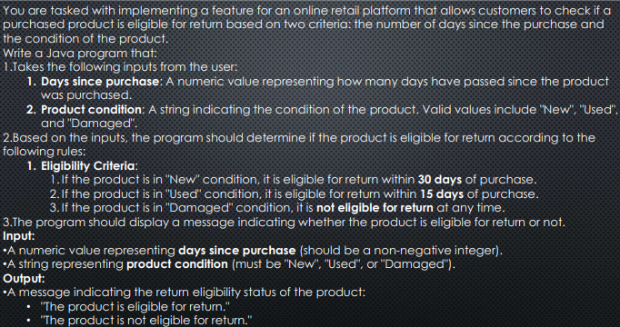

import java.util.Scanner;

public class producteligible {

    public static void main(String[] args) {

        Scanner scanner = new Scanner(System.in);

        System.out.print("Enter How many days have passed since the product was purchased :-> ");

        int days = scanner.nextInt();

        scanner.nextLine();

        if (days < 0) {

            System.out.println("Error : Number should be a non-negative integer");

        } else {

            System.out.print("Enter condition of the Product [New/Used/Damaged] :-> ");

            String condition = scanner.nextLine();

            if (condition.equalsIgnoreCase("New")) {

                if (days <= 30) {

                    System.out.println("The product is eligible for return");

                } else {

                    System.out.println("The product is not eligible fo return");

                }

            } else if (condition.equalsIgnoreCase("Used")) {

                if (days <= 15) {

                    System.out.println("The product is eligible for return");

                } else {

                    System.out.println("The product is not eligible fo return");

                }

            } else if (condition.equalsIgnoreCase("Damaged")) {

                System.out.println("It is not eligible for return at any time");

            } else {

                System.out.println("Sry! Invalid Input, Please enter [New/Used/Damaged]");

            }

        }

        scanner.close();

    }

}

Enter How many days have passed since the product was purchased :-> 12

Enter condition of the Product [New/Used/Damaged] :-> Damaged

It is not eligible for return at any time

Enter How many days have passed since the product was purchased :-> 14

Enter condition of the Product [New/Used/Damaged] :-> Used

The product is eligible for return

Enter How many days have passed since the product was purchased :-> 29

Enter condition of the Product [New/Used/Damaged] :-> NEw

The product is eligible for return

Enter How many days have passed since the product was purchased :-> 18

Enter condition of the Product [New/Used/Damaged] :-> Used

The product is not eligible fo return

12>>>

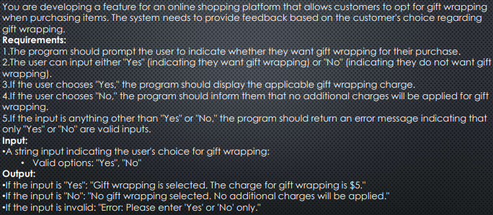

import java.util.Scanner;

public class giftwrapping {

    public static void main(String[] args) {

    Scanner scanner = new Scanner(System.in);

    System.out.print("Do you want gift wrapping for you purchase? Enter [yes/no] :-> ");

    String giftWrapping = scanner.nextLine();

    if (giftWrapping.equalsIgnoreCase("Yes")) {

        System.out.println("Gift wrapping is selected. The charge for gift wrapping is 5");

    } else if (giftWrapping.equalsIgnoreCase("No")) {

        System.out.println("No Gift wrapping selected. No additional charges will be applied");

    } else {

        System.out.println("Error: Please enter 'Yes' or 'No' only");

    }

    scanner.close();

    }

}

Do you want gift wrapping for you purchase? Enter [yes/no] :-> yes

Gift wrapping is selected. The charge for gift wrapping is 5

Do you want gift wrapping for you purchase? Enter [yes/no] :-> n

Error: Please enter 'Yes' or 'No' only

Do you want gift wrapping for you purchase? Enter [yes/no] :-> no

No Gift wrapping selected. No additional charges will be applied

13>>>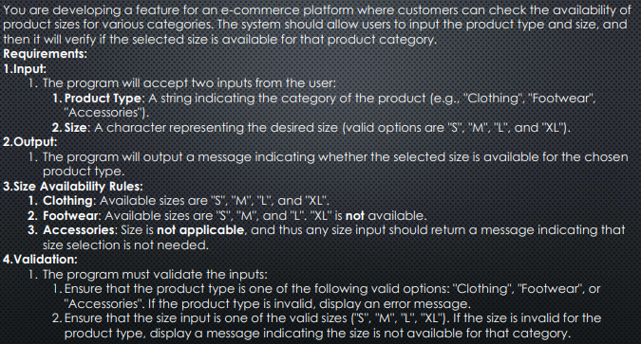>>>

import java.util.Scanner;

public class productsize {

    public static void main(String[] args) {

        Scanner scanner = new Scanner(System.in);

        System.out.print("Enter product Type [Clothing, Footwear, Accessories] :-> ");

        String productType = scanner.nextLine();

        if (productType.equalsIgnoreCase("Clothing")) {

            System.out.print("Enter size [S/M/L/XL] :-> ");

            String size = scanner.nextLine();

            if (size.equalsIgnoreCase("S") || size.equalsIgnoreCase("M") || size.equalsIgnoreCase("L")

                    || size.equalsIgnoreCase("XL")) {

                System.out.println("The selected size is available for clothing");

            } else {

                System.out.println("Invalid size. Available sizes for clothing are S,M,L,XL");

            }

        } else if (productType.equalsIgnoreCase("Footwear")) {

            System.out.print("Enter size [S/M/L] :-> ");

            String size = scanner.nextLine();

            if (size.equalsIgnoreCase("S") || size.equalsIgnoreCase("M") || size.equalsIgnoreCase("L")) {

                System.out.println("The selected size is available for Footwear");

            } else if (size.equalsIgnoreCase("XL")) {

                System.out.println("Size XL is not available for Footwear");

            } else {

                System.out.println("Invalid size. Available sizes for Footwear are S,M,L");

            }

        } else if (productType.equalsIgnoreCase("Accessories")) {

            System.out.println("Size selection is not needed for Accessories");

        } else {

            System.out.println("Error : Invalid Product Type. Please Enter clothing, Footwear, Accessories");

        }

        scanner.close();

    }

}

Enter product Type [Clothing, Footwear, Accessories] :-> clothing

Enter size [S/M/L/XL] :-> S

The selected size is available for clothing

Enter product Type [Clothing, Footwear, Accessories] :-> Footwear

Enter size [S/M/L] :-> L

The selected size is available for Footwear

Enter product Type [Clothing, Footwear, Accessories] :-> footwear

Enter size [S/M/L] :-> XL

Size XL is not available for Footwear

Enter product Type [Clothing, Footwear, Accessories] :-> clothin

Error : Invalid Product Type. Please Enter clothing, Footwear, Accessories

14>>>

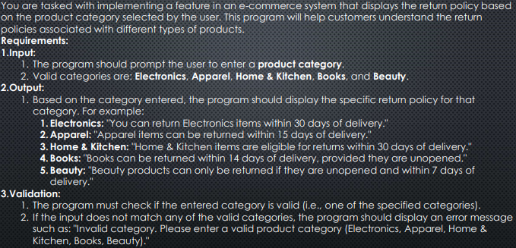

import java.util.Scanner;

public class productCategory {

    public static void main(String[] args) {

        Scanner scanner = new Scanner(System.in);

        System.out.print("Enter a Product Category [Electronics, Apparel, Home & kitchen, Books, Beauty] :-> ");

        String category = scanner.nextLine();

        switch (category.toLowerCase()) {

            case "electronics":

                System.out.println("you can return Electronics items within 30 days of delievery");

                break;

            case "apparel":

                System.out.println("Apparel items can be returned within 15 days of delivery");

                break;

            case "home & kitchen":

                System.out.println("Home & Kitchen items are eligible for returns within 30 days of delivery");

                break;

            case "books":

                System.out.println("Books can be returned within 14 days of delivery, provided they are unopened");

                break;

            case "beauty":

                System.out.println(

                        "Beauty products can only be returned if they are unopened and within 7 days of delivery.");

                break;

            default:

                System.out.println("Invalid Category. Please enter a valid Product Category");

                break;

        }

        scanner.close();

    }

}

Enter a Product Category [Electronics, Apparel, Home & kitchen, Books, Beauty] :-> Apparel

Apparel items can be returned within 15 days of delivery

Enter a Product Category [Electronics, Apparel, Home & kitchen, Books, Beauty] :-> Books

Books can be returned within 14 days of delivery, provided they are unopened

Enter a Product Category [Electronics, Apparel, Home & kitchen, Books, Beauty] :-> Electronic

Invalid Category. Please enter a valid Product Category

Enter a Product Category [Electronics, Apparel, Home & kitchen, Books, Beauty] :-> electronics

you can return Electronics items within 30 days of delievery

Enter a Product Category [Electronics, Apparel, Home & kitchen, Books, Beauty] :-> Home & Kitchen

Home & Kitchen items are eligible for returns within 30 days of delivery

15>>>

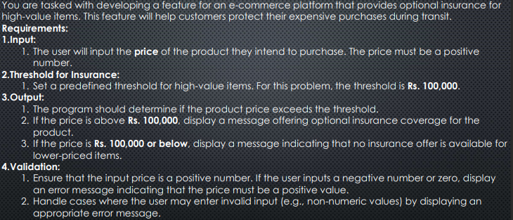

import java.util.Scanner;

public class optionalinsurance {

    public static void main(String[] args) {

    Scanner scanner = new Scanner(System.in);

    double threshold = 100000;

    System.out.print("Enter price of product :-> ");

    double price = scanner.nextDouble();

    if (price <= 0) {

        System.out.println("Error : The price must be a positive number");

    } else if (price > threshold) {

        System.out.println("The product qualifies for optional insurance coverage");

    } else if (price <= threshold) {

        System.out.println("No insurance offer is available for lower-priced items");

    } else {

        System.out.println("Invalid input");

    }

    scanner.close();

    }

}

Enter price of product :-> 100001

The product qualifies for optional insurance coverage

Enter price of product :-> 100000

No insurance offer is available for lower-priced items

16>>>

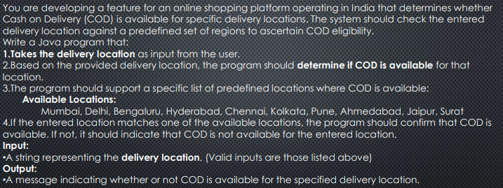

import java.util.Scanner;

public class cashOnDelivery {

    public static void main(String[] args) {

        Scanner scanner = new Scanner(System.in);

        System.out.print("Enter Delivery Location :-> ");

        String location = scanner.nextLine();

        if (location.equalsIgnoreCase("Mumbai") || location.equalsIgnoreCase("Delhi") ||

                location.equalsIgnoreCase("Bangalore") || location.equalsIgnoreCase("Hyderabad") ||

                location.equalsIgnoreCase("Chennai") || location.equalsIgnoreCase("Kolkata") ||

                location.equalsIgnoreCase("Pune") || location.equalsIgnoreCase("Ahmedabad") ||

                location.equalsIgnoreCase("Jaipur") || location.equalsIgnoreCase("Surat")) {

            System.out.println("COD is available for " + location);

        } else {

            System.out.println("COD is not available for " + location);

        }

        scanner.close();

    }

}

Enter Delivery Location :-> Jaipur

COD is available for Jaipur

Enter Delivery Location :-> Goa

COD is not available for Goa

Enter Delivery Location :-> Patna

COD is not available for Patna

Enter Delivery Location :-> Bangalore

COD is available for Bangalore

Enter Delivery Location :-> Pune

COD is available for Pune

Enter Delivery Location :-> Jaipur

COD is available for Jaipur

17>>>

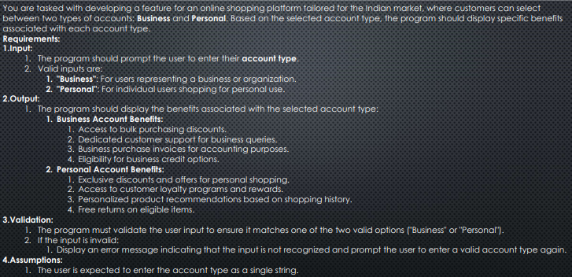

import java.util.Scanner;

public class Shoppingplatform {

    public static void main(String[] args) {

        Scanner scanner = new Scanner(System.in);

        System.out.print("Enter Account Type [Business / Personal] :-> ");

        String accType = scanner.nextLine();

        switch (accType.toLowerCase()) {

            case "business":

                System.out.println("--- Business Account Benefits ---");

                System.out.println("1> Access to bulk purchasing discounts.");

                System.out.println("2> Dedicated customer support for business queries.");

                System.out.println("3> Business purchase invoices for accounting purposes.");

                System.out.println("4> Eligibility for business credit options.");

                break;

            case "personal":

                System.out.println(">>> Personal Account Benefits <<<");

                System.out.println("1>  Exclusive discounts and offers for personal shopping.");

                System.out.println("2>  Access to customer loyality program and rewards.");

                System.out.println("Personalized product recommendations based on shopping history.");

                System.out.println("Free returns on eligible items.");

                break;

            default:

                System.out.println("Invalid Input.");

                break;

        }

        scanner.close();

    }

}

Enter Account Type [Business / Personal] :-> business

--- Business Account Benefits ---

1> Access to bulk purchasing discounts.

2> Dedicated customer support for business queries.

3> Business purchase invoices for accounting purposes.

4> Eligibility for business credit options.

Enter Account Type [Business / Personal] :-> personal

>>> Personal Account Benefits <<<

1> Exclusive discounts and offers for personal shopping.

2> Access to customer loyality program and rewards.

Personalized product recommendations based on shopping history.

Free returns on eligible items.

Enter Account Type [Business / Personal] :-> saving

The input is not recognized & enter a valid account type again.

19>>>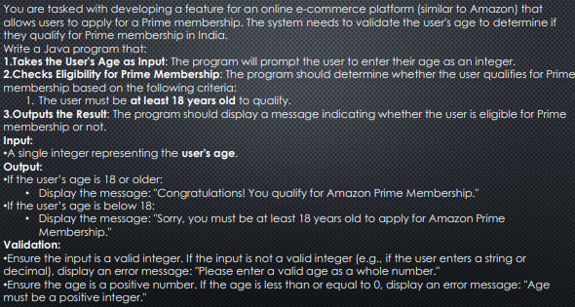

import java.util.Scanner;

public class membership {

    public static void main(String[] args) {

        Scanner scanner = new Scanner(System.in);

        System.out.print("Enter Your Age :-> ");

        if (scanner.hasNextInt()) {

            int age = scanner.nextInt();

            if (age < 0) {

                System.out.println("Age must be a positive integer");

            } else if (age >= 18 && age < 100) {

                System.out.println("Congratulations! You qualify for Amazon Prime MemberShip");

            } else {

                System.out.println("Sorry,You must be at least 18 years old to apply for Amazon Prime Membership");

            }

        } else {

            System.out.println("Error : Please enter a valid age as a whole number");

        }

        scanner.close();

    }

}

Enter Your Age :-> -23

Age must be a positive integer

Enter Your Age :-> atwr

Error : Please enter a valid age as a whole number

Enter Your Age :-> 234.024

Error : Please enter a valid age as a whole number

Enter Your Age :-> 17

Sorry,You must be at least 18 years old to apply for Amazon Prime Membership

Enter Your Age :-> 24

Congratulations! You qualify for Amazon Prime MemberShip

20>>>

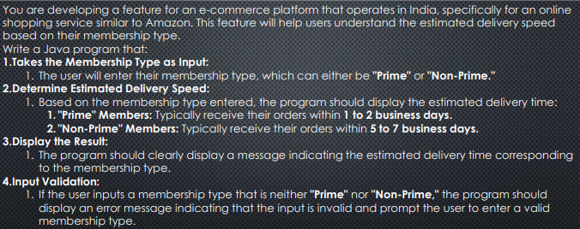

import java.util.Scanner;

public class deliveryspeed {

    public static void main(String[] args) {

        Scanner scanner = new Scanner(System.in);

        System.out.print("Enter your membership type [prime / Non-prime] :-> ");

        String membership = scanner.nextLine();

        if (membership.equalsIgnoreCase("prime")) {

            System.out.println("Estimated Delivery Time : Typically receive their order within 1 to 2 Business Days.");

        } else if (membership.equalsIgnoreCase("Non-Prime")) {

            System.out.println("Estimated Delivery Time : Typically recieve their order within 5 to 7 Business Days.");

        } else {

            System.out.println("Error : Input is invalid. Please enter a valid membership type.");

        }

        scanner.close();

    }

}

Enter your membership type [prime / Non-prime] :-> prime

Estimated Delivery Time : Typically receive their order within 1 to 2 Business Days.

Enter your membership type [prime / Non-prime] :->

Error : Input is invalid. Please enter a valid membership type.

Enter your membership type [prime / Non-prime] :-> Non-prime

Estimated Delivery Time : Typically recieve their order within 5 to 7 Business Days.

21>>>

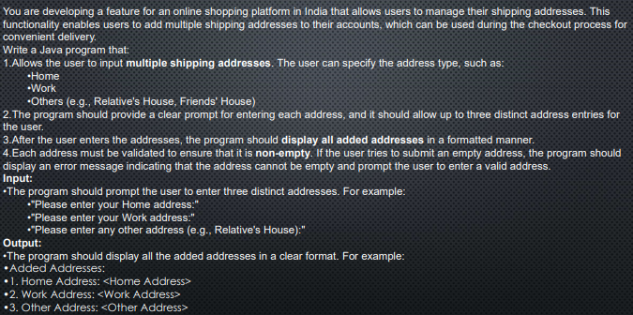

import java.util.Scanner;

public class shipingAddress {

    public static void main(String[] args) {

        Scanner scanner = new Scanner(System.in);

        System.out.print("Please Enter your Home Address :-> ");

        String Home = scanner.nextLine();

        System.out.print("Please Enter your Work Address :-> ");

        String Work = scanner.nextLine();

        System.out.print("Please Enter Any other Address :-> ");

        String Other = scanner.nextLine();

        if (Home.equals(" ") || Work.equals(" ") || Other.equals(" ")) {

            System.out.println("Error : Please Enter a valid Address");

        } else {

            System.out.println("1>   Home Addresses : " + Home);

            System.out.println("2>   Work Addresses : " + Work);

            System.out.println("3>   Other Addresses : " + Other);

        }

        scanner.close();

    }

}

Please Enter your Home Address :-> Patna

Please Enter your Work Address :-> Patna

Please Enter Any other Address :-> Banglore

1> Home Addresses : Patna

2> Work Addresses : Patna

3> Other Addresses : Banglore

Please Enter your Home Address :-> Kolkata

Please Enter your Work Address :->

Please Enter Any other Address :-> Goa

Error : Please Enter a valid Address

23>>>

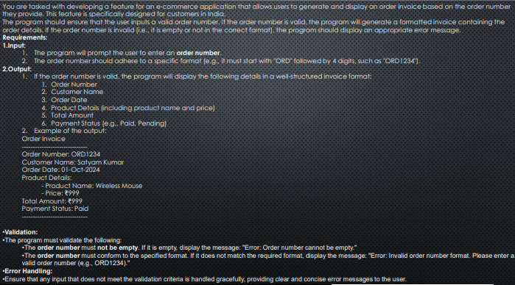

import java.util.Scanner;

public class orderinvoice {

    public static void main(String[] args) {

        Scanner scanner = new Scanner(System.in);

        System.out.print("Enter your order number (such as ORD1234) :-> ");

        String orderNumber = scanner.nextLine();

        if (orderNumber.equals(" ")) {

            System.out.println("Error: Order number cannot be empty");

        } else if (orderNumber.length() == 7 && orderNumber.startsWith("ORD")) {

            char c1 = orderNumber.charAt(3);

            char c2 = orderNumber.charAt(4);

            char c3 = orderNumber.charAt(5);

            char c4 = orderNumber.charAt(6);

            if ((c1 >= '0' && c1 <= '9') && (c2 >= '0' && c2 <= '9') && (c3 >= '0' && c3 <= '9')

                    && (c4 >= '0' && c4 <= '9')) {

                System.out.println("Order Invoice");

                System.out.println("--------------------------------------");

                System.out.println("Order Number : " + orderNumber);

                System.out.println("Customer Name: Patrick Bateman");

                System.out.println("Order Date: 17-Dec-2024");

                System.out.println("Product Details:");

                System.out.println("- Product Name: Bat Suit");

                System.out.println("- Price: 99999999");

                System.out.println("Total Amount: 99999999");

                System.out.println("Payment Status: Paid");

                System.out.println("------------------------------");

            } else {

                System.out.println("Error: Invalid Order Number Format. Please Enter valid order number");

            }

        } else {

            System.out.println("Invalid Order Number");

        }

        scanner.close();

    }

}

Enter your order number (such as ORD1234) :-> ORD3000

Order Invoice

--------------------------------------

Order Number : ORD3000

Customer Name: Patrick Bateman

Order Date: 17-Dec-2024

Product Details:

- Product Name: Bat Suit

- Price: 99999999

Total Amount: 99999999

Payment Status: Paid

------------------------------

24>>>

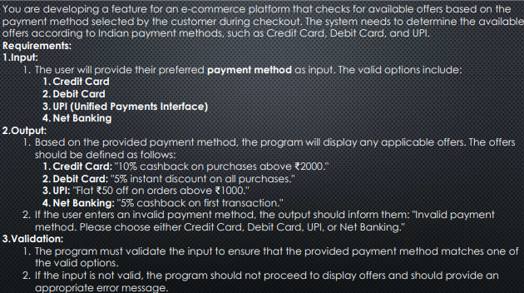

import java.util.Scanner;

public class paymentOffers {

    public static void main(String[] args) {

        Scanner scanner = new Scanner(System.in);

        System.out.print("Enter your preffered payment Method [Credit Card, Debit Card, UPI, Net Banking] :-> ");

        String paymentMethod = scanner.nextLine();

        if (paymentMethod.equalsIgnoreCase("Credit Card")) {

            System.out.println("Offer: 10% cashback on purchases above 2000.");

        } else if (paymentMethod.equalsIgnoreCase("Debit Card")) {

            System.out.println("Offer: 5% instant discount on all purchases.");

        } else if (paymentMethod.equalsIgnoreCase("UPI")) {

            System.out.println("Offer: Flat 50 off on orders above 1000.");

        } else if (paymentMethod.equalsIgnoreCase("Net Banking")) {

            System.out.println("Offer: 5% cashback on first transaction.");

        } else {

            System.out.println(

                    "Invalid payment method. Please choose either Credit Card, Debit Card, UPI, or Net Banking.");

        }

        scanner.close();

    }

}

Enter your preffered payment Method [Credit Card, Debit Card, UPI, Net Banking] :-> wer

Invalid payment method. Please choose either Credit Card, Debit Card, UPI, or Net Banking.

Enter your preffered payment Method [Credit Card, Debit Card, UPI, Net Banking] :-> Credit card

Offer: 10% cashback on purchases above 2000.

Enter your preffered payment Method [Credit Card, Debit Card, UPI, Net Banking] :-> UPI

Offer: Flat 50 off on orders above 1000.

Enter your preffered payment Method [Credit Card, Debit Card, UPI, Net Banking] :-> Debit Card

Offer: 5% instant discount on all purchases.

Enter your preffered payment Method [Credit Card, Debit Card, UPI, Net Banking] :-> Net Banking

Offer: 5% cashback on first transaction.

18>>>

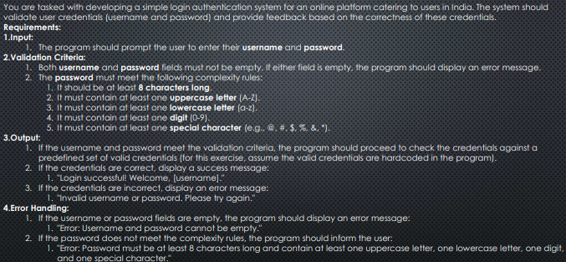

22>>>

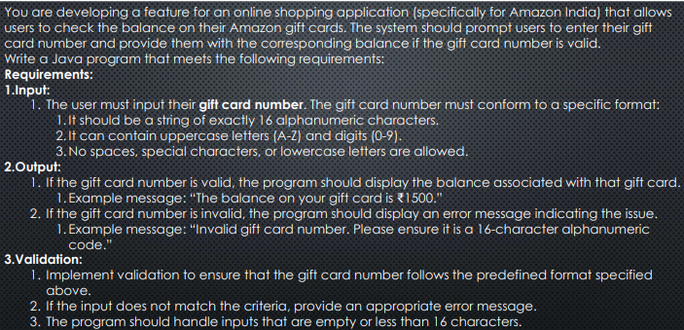

25>>>

